

**Embedded Systems Lab Submission**

**BTech, III Yr, V Sem**

**Dept. of IT**

**AY: 2022-2023**

**Submitted by**

**NAME: Saakar Chaudhary**

**ROLL NO: A009**

**SAP ID: 70012000195**

**BATCH: A1**

INDEX

|  |  |  |  |  |
| --- | --- | --- | --- | --- |
| Sr. No. | Lab No. | Name of Experiment | Date | Sign |
| 1 | Lab 1 | Simulation of 4 LEDs using Arduino Nano | 03/08/22 |  |
| 2 | Lab 2 | Simulation of 16x2 LCD using Arduino UNO | 03/08/22 |  |
| 3 | Lab 3 | Simulation of Arduino uno based board for running multiple servo motor in SimulIDE | 10/08/22 |  |
| 4 | Lab 4 | Simulation of Digital Clock on SimulIDE | 17/08/22 |  |
| 5 | Lab 5a | DHT Sensor connected to ESP32 microcontroller using WokWi open source | 24/08/22 |  |
| 6 | Lab 5b | DHT Sensor connected to Arduino UNO using WokWi open source | 24/08/22 |  |
| 7 | Lab 6a | To Implement Snake Game in Simulide using Arduino Nano | 07/09/22 |  |
| 8 | Lab 6b | To Implement Marduino Game in Simulide using Arduino Nano | 07/09/22 |  |
| 9 | Lab 7 | Traffic Lights system with Arduino and SimulIDE | 14/09/22 |  |
| 10 | Lab 8 | Round Robin scheduling algorithm | 21/09/22 |  |
| 11 | Lab 9 | 8051 Microcontroller Simulation on virtual lab | 21/09/22 |  |
| 12 | Lab 10 | Blinking of LED in 8051 microcontroller | 28/09/22 |  |
| 13 | Lab 11 | Blinking of LED using Arduino Nano | 28/09/22 |  |
| 14 | Lab 12 | Blinking LED on Rasberry pi | 12/10/22 |  |
| 15 | Lab 13 | Case Study- Applications of FreeRTOS | 12/10/22 |  |

**LAB 1**

**Title: Simulation of 4 LEDs using Arduino Nano**

**Aim:** To develop a circuit of 4 LEDs and to program it using Arduino Nano.

**Apparatus:** Components Used:

1. LED
2. Arduino Nano
3. Software Used: SimulIDE, Arduino

**Procedure:**

**Hardware Configuration Procedure:**

1. Open SimulIDE application using the SimulIDE.exe file obtained from the bin folder of the SimulIDE extraction folder.
2. Create a new simulation and save it as blink.simu
3. In the simulation panel, add the hardware components mentioned in apparatus.
4. Connect the above components as follows as shown in the below circuit image setup.

Fig.1. Lab 2 – LCD connection with Arduino Uno

**Software Configuration Procedure:**

1. Create a new Arduino program and save it as lcd.ino
2. Type in the program given below and save it.
3. Then set the compiler path to the Arduino folder.
4. Click on the compile button and wait till the display message of ‘**Compilation successful’** is displayed.
5. Then click on the **upload button** and wait till the program uploaded to firmware message is displayed.
   1. If above process is not working check for **blink.ino.hex** stored at

C:\Users\SaakarChaudhary\AppData\Local\simulide\codeeditor\buildIno\build

1. Click on the Power button in the simulation tab to run the program.

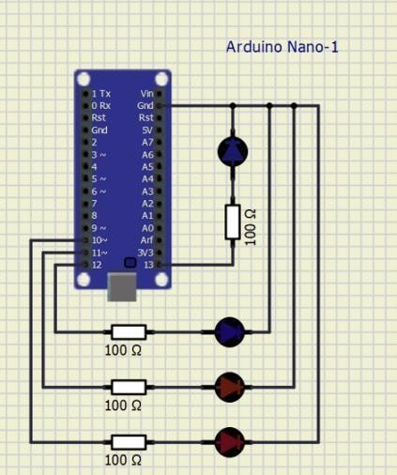

Code:

int LED1 = 13; int LED2 = 12; int LED3 = 11; int LED4 = 10;

void setup(){

pinMode (LED1, OUTPUT); pinMode (LED2, OUTPUT); pinMode (LED3, OUTPUT); pinMode (LED4, OUTPUT);

}

void loop() {

digitalWrite (LED1, HIGH); //turn on LED1 delay(200); //wait for 200ms

digitalWrite (LED2, HIGH); //turn on LED2 delay(200); //wait for 200ms

digitalWrite (LED3, HIGH); //turn on LED3 delay(200); //wait for 200ms

digitalWrite (LED4, HIGH); //turn on LED4 delay(200); //wait for 200ms

digitalWrite (LED1, LOW); //turn off LED 1 delay(300); //wait for 300ms

digitalWrite (LED2, LOW); //turn off LED2 delay(300); //wait for 300ms

digitalWrite (LED3, LOW); //turn off LED3 delay(300); //wait for 300ms

digitalWrite (LED4, LOW); //turn off LED4

delay(300); //wait for 300ms before running code all over again

}

**Output Screenshots:**

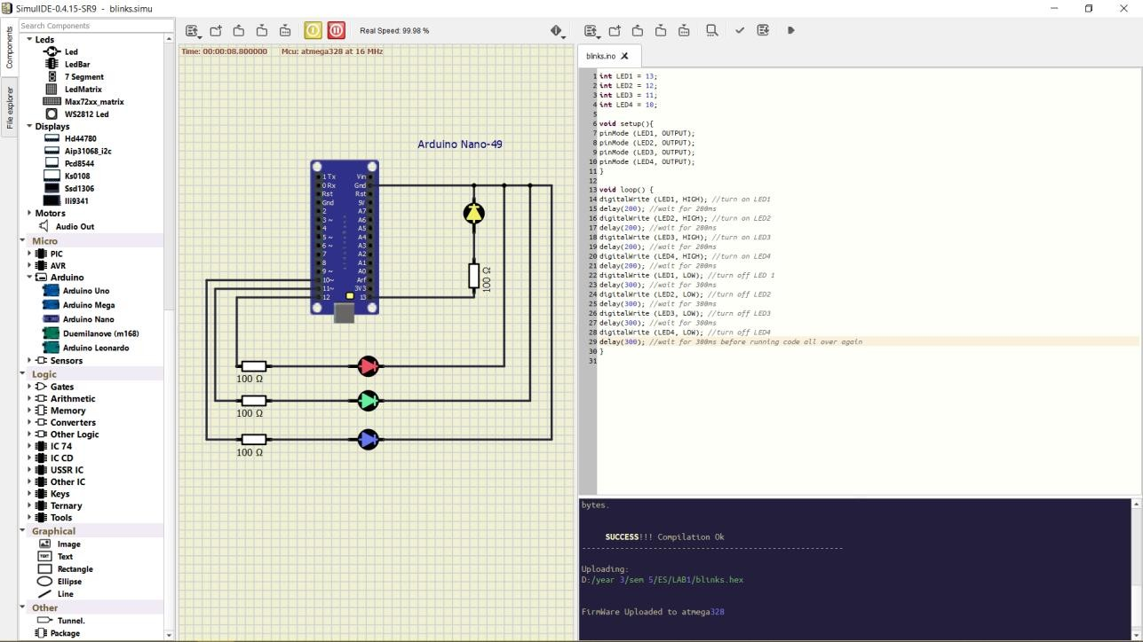

**Observations:** (Please write your observations as per the lab you implemented)

* 1. The LEDs light up and power down in an order by the code.
  2. The delay can also be setup using the code.
  3. The Arduino Nano output pins and input pins are connected to the LED display.

**Conclusion:** (Write the conclusion based on your understanding)

We developed a circuit of 4 LEDs and to programmed it using Arduino Nano

.

**LAB 2**

**Title: Simulation of 16x2 LCD using Arduino UNO**

**Aim:** To develop a circuit of 16x2 LCD and to program it using Arduino UNO.

**Apparatus:** Components Used:

1. Hd44780 (16x2 LCD)
2. Arduino UNO
3. Software Used: SimulIDE, Arduino

**Procedure:**

**Hardware Configuration Procedure:**

1. Open SimulIDE application using the SimulIDE.exe file obtained from the bin folder of the SimulIDE extraction folder.
2. Create a new simulation and save it as lcd.simu
3. In the simulation panel, add the hardware components mentioned in apparatus.
4. Connect the above components as follows as shown in the below circuit image setup.

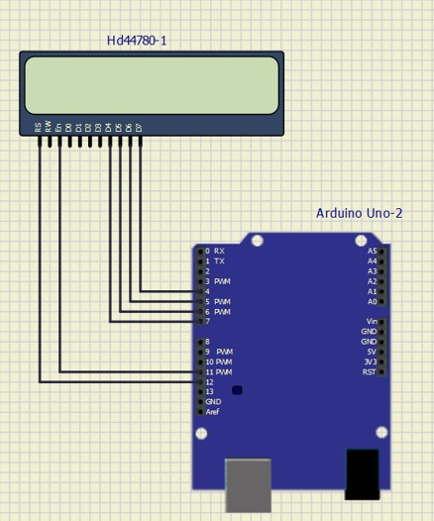

Fig.1. Lab 2 – LCD connection with Arduino Uno

**Software Configuration Procedure:**

1. Create a new Arduino program and save it as lcd.ino 2. Type in the program given below and save it.

1. Then set the compiler path to the Arduino folder.
2. Click on the compile button and wait till the display message of ‘**Compilation successful’** is displayed.
3. Then click on the **upload button** and wait till the program uploaded to firmware message is displayed.

a. If above process is not working check for **lcd.ino.hex** stored at Click on the Power button in the simulation tab to run the program.

Code:

// -----------------------------------------------

// LCD 16x2 HD44780-40

// -----------------------------------------------

#include <LiquidCrystal.h>

int D7_pin = 4; int D6_pin = 5; int D5_pin = 6; int D4_pin = 7; int EN_pin = 11;

int RS_pin = 12;

LiquidCrystal lcd(RS_pin, EN_pin, D4_pin, D5_pin, D6_pin, D7_pin);

void setup() {

lcd.begin(16, 2);

}

void loop() {

lcd.clear();

lcd.print("Embedded Systems Lab"); lcd.setCursor(0, 1);

lcd.print("Name: Prasanna Dalvi");

delay(3000);

lcd.clear();

lcd.print("MPSTME NMIMS");

lcd.setCursor(0, 1);

lcd.print("Roll no.: 003");

delay(3000);

}

**Output Screenshots: (take screenshots of atleast 3 different outputs) Compilation Process: take screenshot of compilation.**

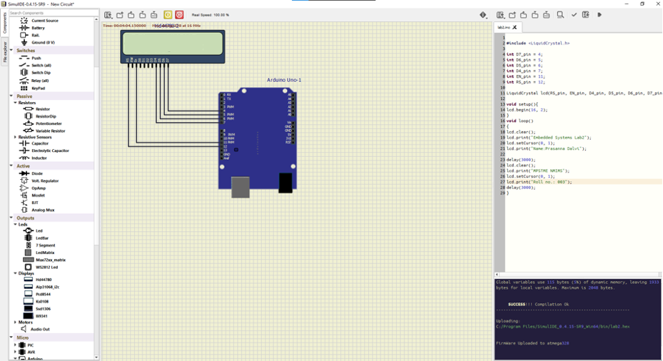

**Observations:** (Please write your observations as per the lab you implemented)

1. The displayed text can be changed by changing the string values in the code.
2. The delay can also be setup using the code.
3. The Arduino UNO output pins and input pins are connected to the LCD display.
4. The connections are made in such a way that the PWM is attached to D5 and D6 pins of LCD.
5. We used Arduino UNO but we can also use Arduino Nano too.

**Conclusion:** (Write the conclusion based on your understanding)

**Lab 3**

**Aim: To realize the working of Servo motor using Arduino Uno Board.**

**Apparatus:** Oscope, Fixed Voltage, DC Motors, Servo Motor, Arduino Uno Board, connecting Wires.

**Circuit Diagram:**

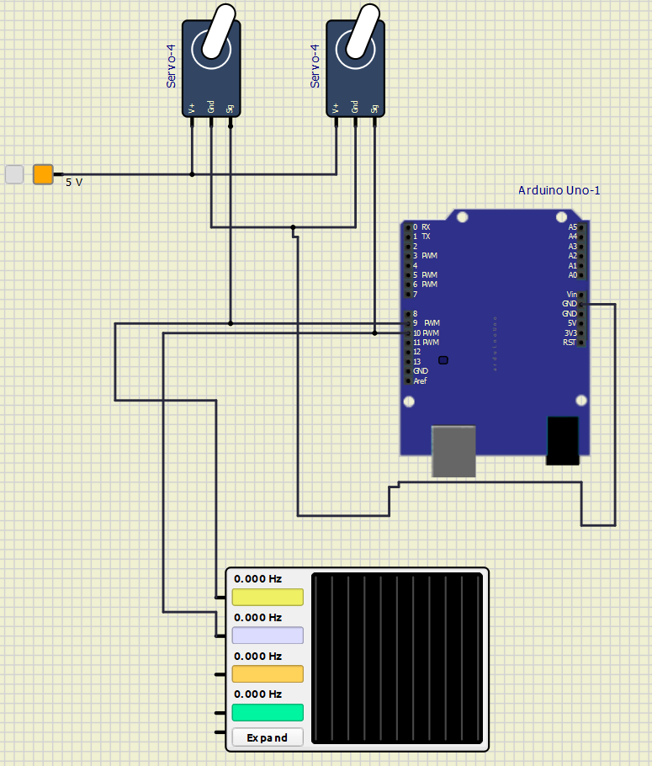

**Procedure:**

**Hardware Configuration/Circuit Building Procedure:**

1. Open SimulIDE application using the SimulIDE.exe file obtained from the bin folder of the SimulIDE extraction folder.

2. Create a new simulation and save it as lab03.simu

3. In the simulation panel, add the hardware components mentioned in apparatus.

4. Connect the above components as follows as shown in the below circuit image setup.

**Software Configuration/Arduino Compilation Procedure:**

1. Create a new Arduino program and save it as lab03.ino

2. Type in the program given below and save it.

3. Then set the compiler path to the Arduino folder.

4. Click on the compile button and wait till the display message of ‘Compilation successful’ is displayed.

5. Then click on the upload button and wait till the program uploaded to firmware message is displayed.

a. If above process is not working check for lab03.ino.hex stored at C:\Users\shrey\AppData\Local\simulide\codeeditor\buildIno\build

6. Click on the Power button in the simulation tab to run the program.

**Code:**

#include<Servo.h>

Servo Myservo1;

Servo Myservo2;

int pos = 0;

void setup()

{

Myservo1.attach(9);

Myservo2.attach(10);

}

void loop()

{

for(pos=0;pos<=180;pos+=1){

Myservo1.write(pos);

Myservo2.write(pos);

delay(15);

}

for(pos=180;pos>=0;pos-=1){

Myservo1.write(pos);

Myservo2.write(pos);

delay(15);

}

//delay(1000);

}

**Final Compilation Screenshot:**

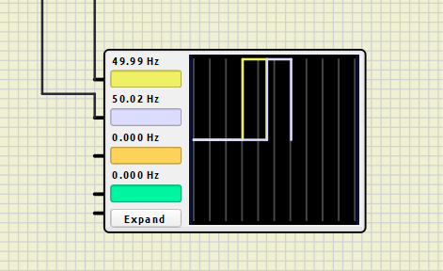

**Conclusion:**

Thus, using SimulIDE, we have executed the working of Servo Motor using Arduino Uno Board

successfully, and displayed the desired results.

**Lab 4**

**Title: Digital clock experiment connected with Arduino NANO in simul IDE software.**

# Aim:

To build a digital clock that shows the time in hours, minutes and seconds using the Logic Gates and IC74 series.

# Apparatus:

Components Used:

1. 7 segment LED display(BCD), 6 in total
2. 5 OR gates
3. 6 AND gates
4. Clock (5V)
5. 2 Pushbuttons
6. 5V fixed Voltage
7. 2 Resistors each of 10k ohms
8. 7-stage ripple carry binary counter, 6 in total
9. 14-stage binary ripple counter
10. Ground terminal
11. wires

Software Used: SimulIDE

# Theory:

A clock that is based off the 7400 Series logic family of ICs. It keeps time in a 24-hour format. The 1 Hz source comes from a 4-pin header and allows to be changed out in the future. An entire clock, built from little more than AND & OR gates, flip-flops, and BCD to seven segment decoders. The core logic of the clock consists of six 4-bit counters (74LS161), driving six 7-segment decoder/drivers (74LS47), which drive 7-segment LED displays. This allows for hours, minutes, and seconds.

# Procedure:

1. Open SimulIDE application using the SimulIDE.exe file obtained from the bin folder of the SimulIDE extraction folder.
2. Create a new simulation and save it as digiclock.simu
3. In the simulation panel, add the hardware components given in apparatus.
4. Connect the above components as shown in circuit setup image.
5. Once the components are connected, we can test the working of the circuit. The output should be all the six 7 segment displays working together in such a way that time is displayed in hours, minutes, and seconds.
6. Click on the Power Circuit button in the simulation tab to run the circuit.

# Circuit Setup:

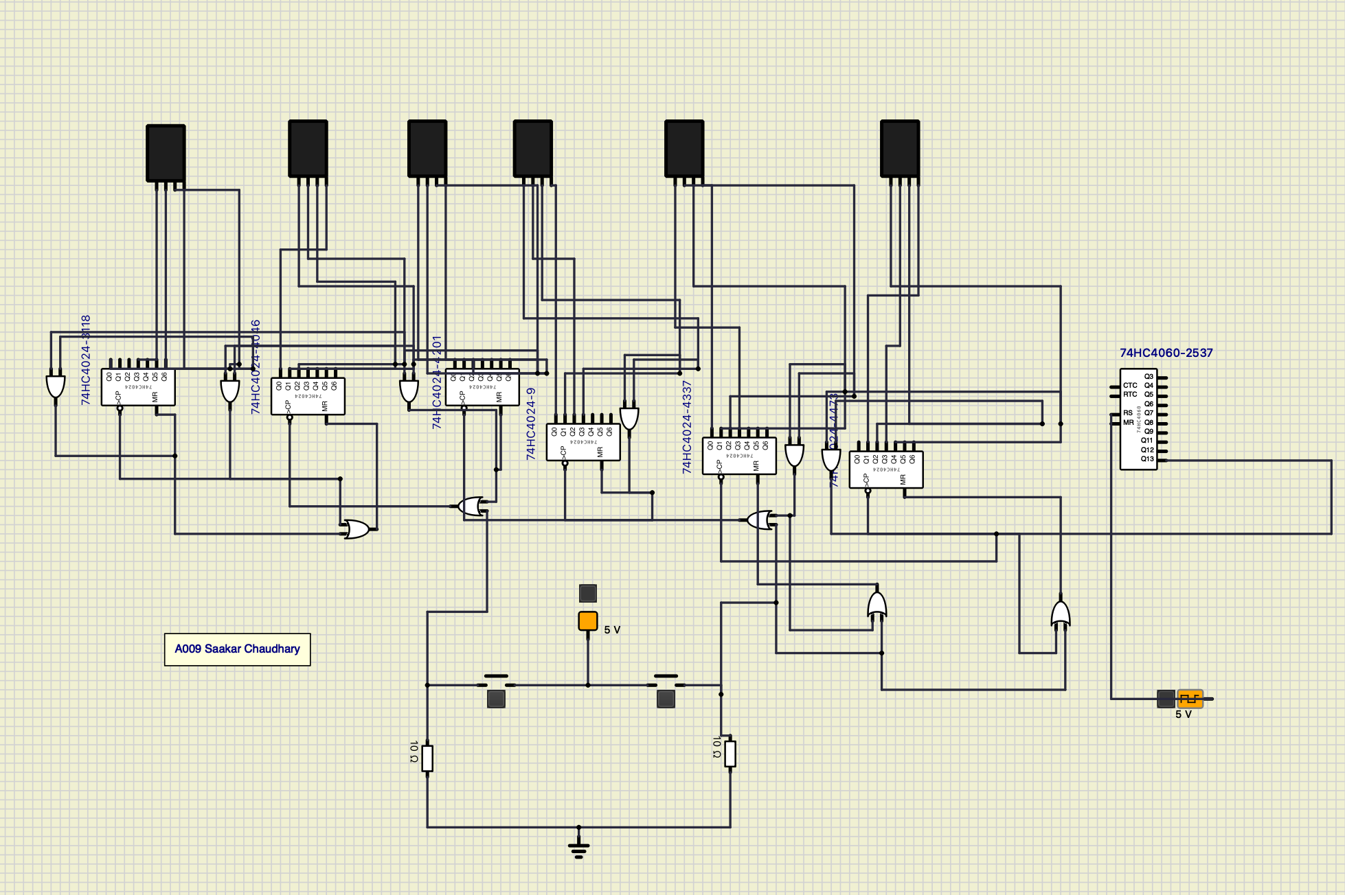



**Screenshots:**

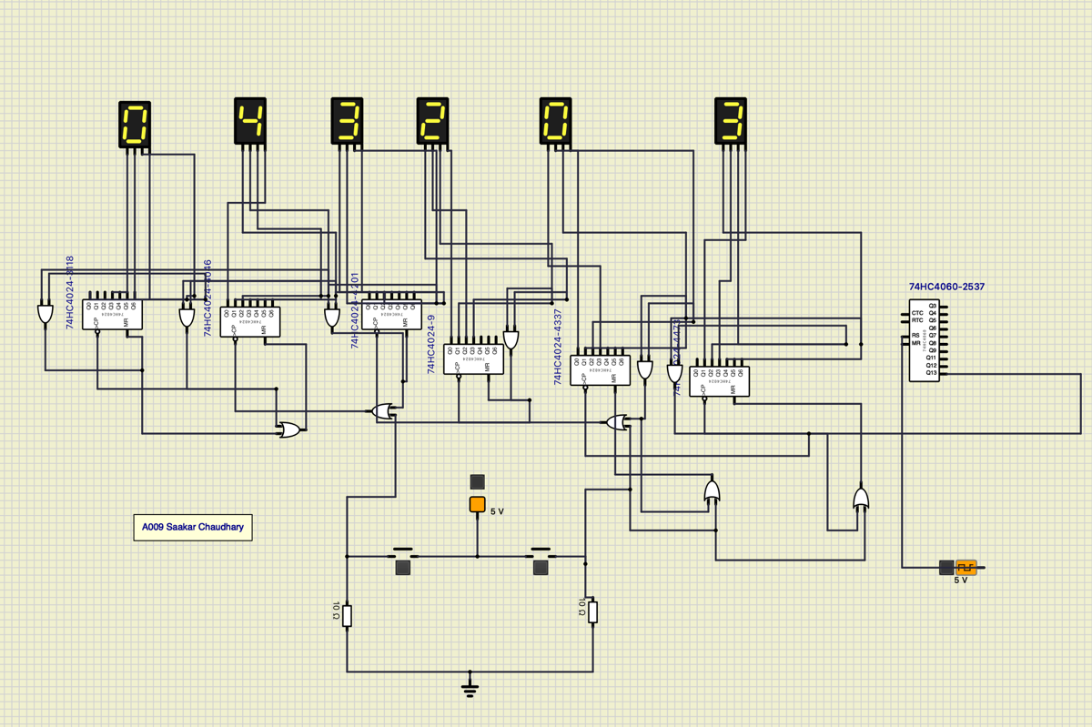



[Time is 04 hours 32 minutes and 03 seconds]

# Observation:

* 1. The clock works in the 24-hour format and displays the time in hours, minutes and seconds format.
  2. The pushbuttons allow us to change the values of the digits in each of the format.
  3. The difference in connections of the microprocessors and the AND and OR gates makes it possible to restrict the values shown in the 7-segment common anode. This means that the clock will reset at 23:59:59 to 00:00:00.

# Conclusion:

Without using Arduino and only using hardware, the number of components used is increased.

**Lab 5**

**Embedded systems lab- Using ESP32 microcontroller using WokWi open source.**

**Aim:** Connect the temperature and humidity sensor and display the values on LED Display interface.

**Apparatus:**

1. ESP32 micro controller

2

. SSD1306 OLED Display

3

. DHT

22

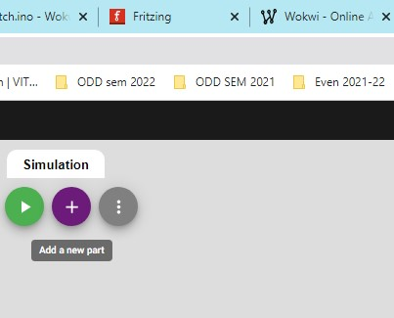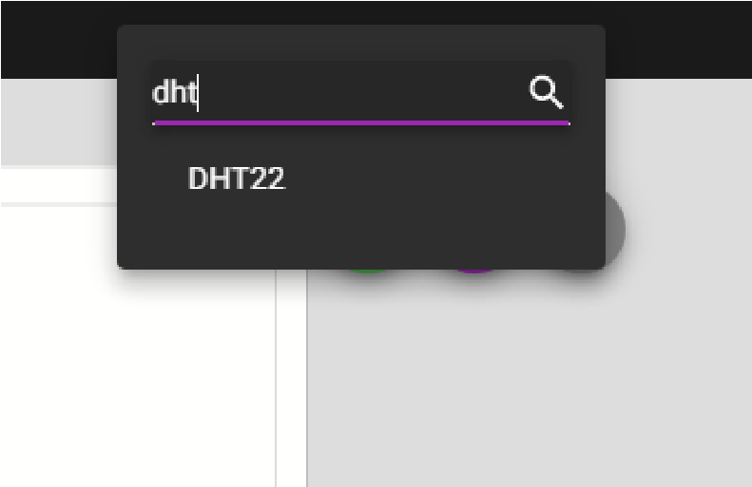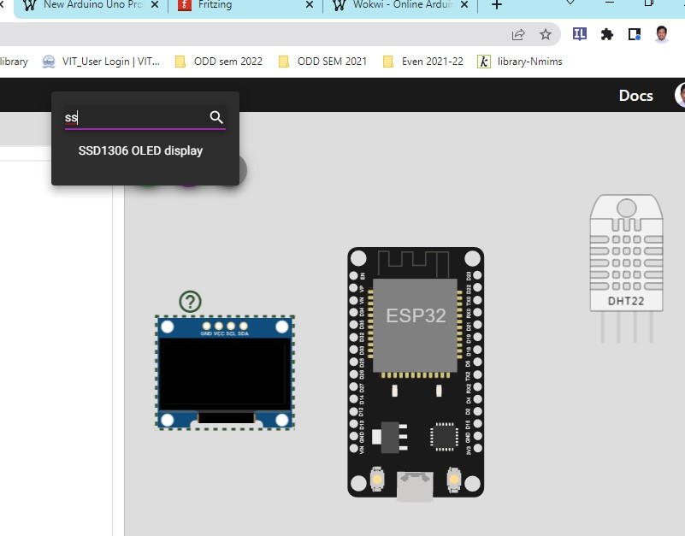

**Circuit Diagram Connection:**

**1.**

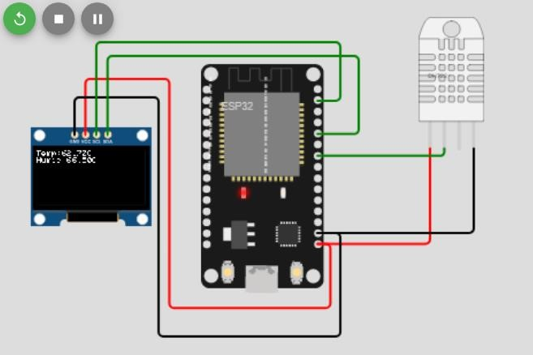

1. **Displaying the D18 pin – the circuit connection same as above.**

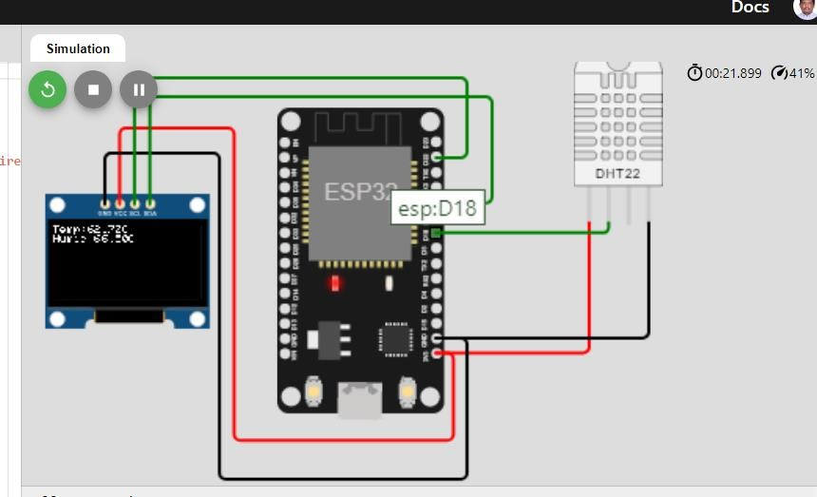

**Adding Libraries:**

In Library Manager, add

1. DHT Sensor Library for ESPx and

2.

Adafruit SSD1306

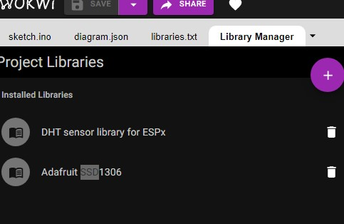

Add above 2 libraries to execute program.

**Program:**

#include <Adafruit_SSD1306.h>

#include<DHTesp.h>

#include<Wire.h>

int DHT_PIN = 18;

Adafruit_SSD1306 display = Adafruit_SSD1306(128,64,&**Wire**);

DHTesp dhtSensor;

void setup() {

// put your setup code here, to run once:

**Serial**.begin(115200);

**Serial**.println("Hello, ESP32!");

dhtSensor.setup(DHT_PIN, DHTesp::DHT22);

//dhtSensor.begin();

display.begin(SSD1306_SWITCHCAPVCC, 0x3C); display.display(); display.setTextSize(1); display.setTextColor(WHITE);

} void loop() {

// put your main code here, to run repeatedly: delay(10); // this speeds up the simulation

display.clearDisplay(); display.setCursor(0,0);

TempAndHumidity data = dhtSensor.getTempAndHumidity();

**Serial**.println("Temp:" + String(data.temperature,2)+"C");

**Serial**.println("Humid:" + String(data.humidity,2)+"C");

display.println("Temp:" + String(data.temperature,2)+"C"); display.println("Humid:" + String(data.humidity,2)+"C");

display.display(); delay(100);

}

**Output:**

1. Click on the DHT22 sensor then you can set the Temperature and Humidity levels as required.
2. The same will be displayed on the LED display and below the circuit diagram as shown in the below picture. **Output 1:**

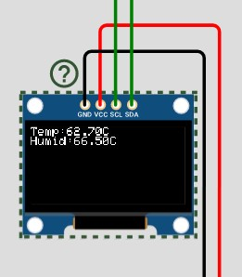

Output 2:

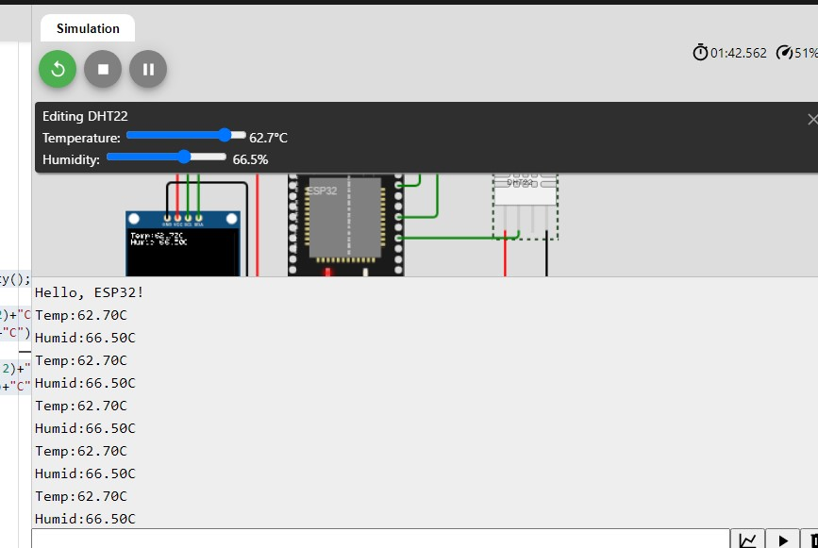

References:

1. <https://wokwi.com/projects/new/esp32>
2. <https://dl.espressif.com/dl/package_esp32_index.json>
3. <http://arduino.esp8266.com/stable/package_esp8266com_index.json>
4. https://wokwi.com/projects/341407606699459156

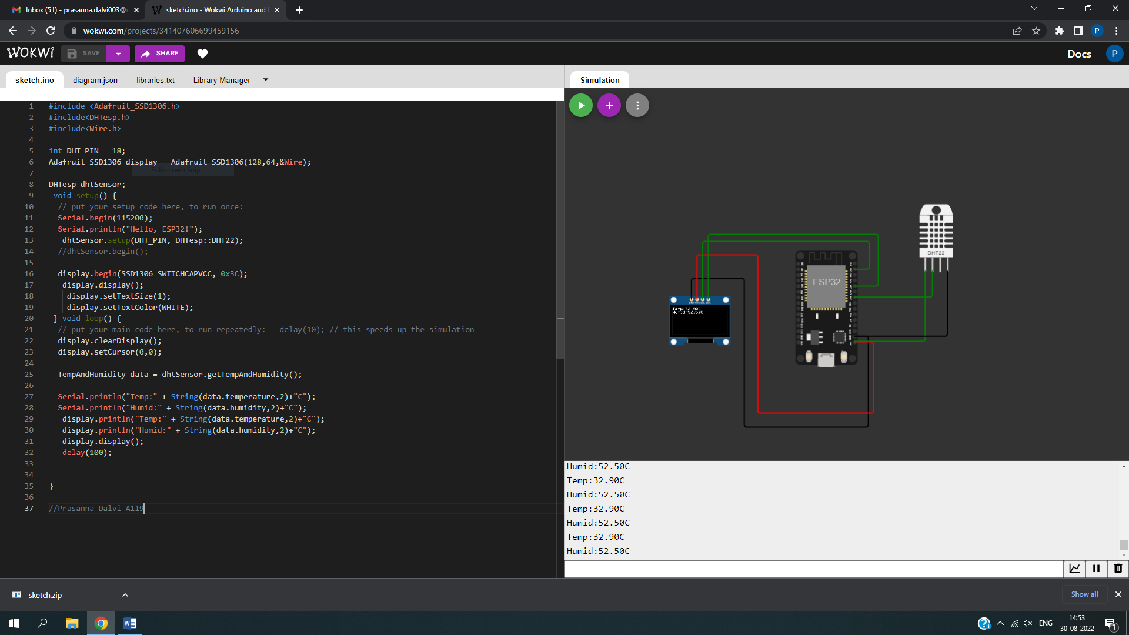

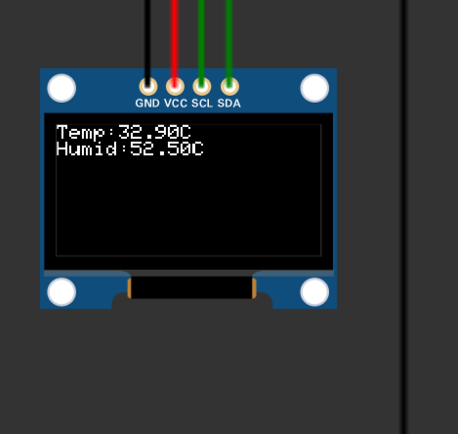

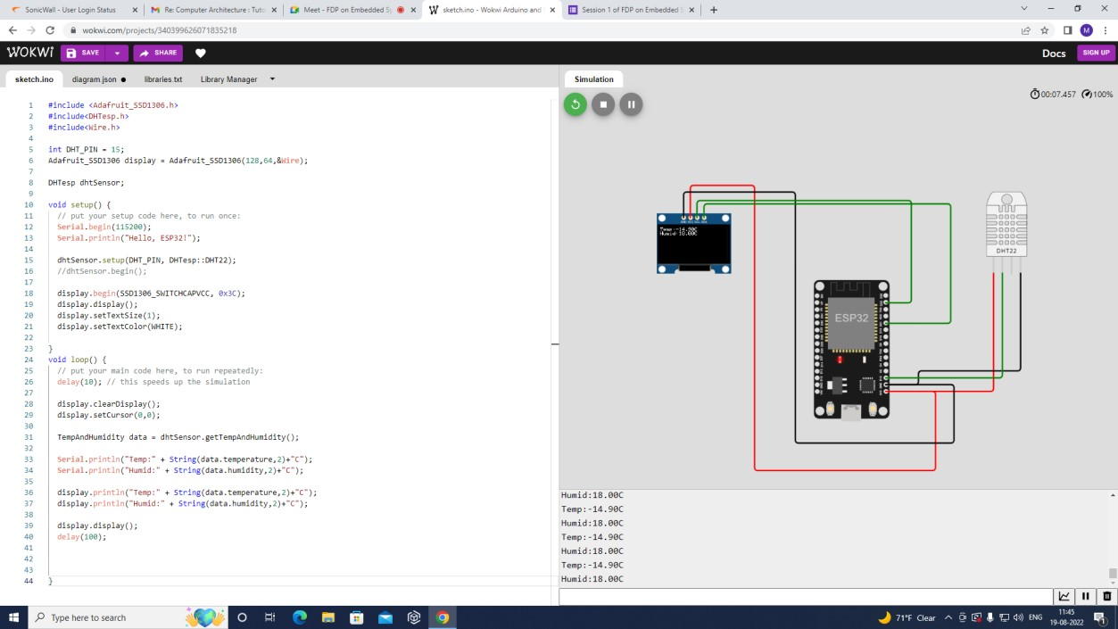

Conclusion: In this practical we implemented and tested humidity and temperature sensor using ESP32 microcontroller.

Lab 6 A

Aim: To Implement Snake Game in Simulided

Apparatus: Simulide, Arduino, Arduino Nano , PCD-8455, Buttons, Wire , Resistor

Circuit Diagram:

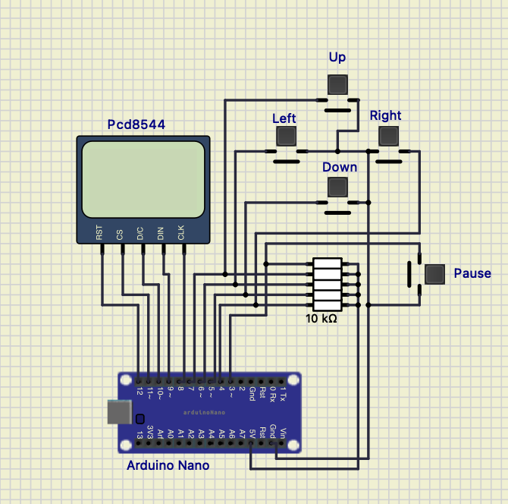

Code:

/**** Snake Game by Abhinav Faujdar *****/

#include <EEPROM.h>

#include <Adafruit_GFX.h>

#include <Adafruit_PCD8544.h>

Adafruit_PCD8544 display = Adafruit_PCD8544(8, 9, 10, 11, 12); //Initialise display object

// pin 7 - Serial clock out (SCLK)

// pin 6 - Serial data out (DIN)

// pin 5 - Data/Command select (D/C)

// pin 4 - LCD chip select (CS)

// pin 3 - LCD reset (RST)

/********* constants *******/

#define UP 7

#define LEFT 6

#define DOWN 5

#define RIGHT 4

#define PAUSE 3

#define MAX_WIDTH 84 //display 84x48

#define MAX_HEIGHT 48

#define speakerPin 2

boolean dl=false,dr=false,du=false,dd=false; // to check in which direction the snake is currently moving

int x[200],y[200],i,slength,tempx=10,tempy=10,xx,yy;

unsigned int high;

uint8_t bh,bl;

int xegg,yegg;

int freq,tb;

int l,r,u,d,p;

unsigned long time=280,beeptime=50;

int score=0,flag=0;

void setup()

{

Serial.begin(9600); //Begin Serial Communication

display.begin();

display.clearDisplay();

pinMode(LEFT,INPUT); //Directional keys and pause

pinMode(RIGHT,INPUT);

pinMode(UP,INPUT);

pinMode(DOWN,INPUT);

pinMode(PAUSE,INPUT);

pinMode(speakerPin,OUTPUT); //Buzzer pin

digitalWrite(LEFT,HIGH); //Active low keys

digitalWrite(RIGHT,HIGH);

digitalWrite(UP,HIGH);

digitalWrite(DOWN,HIGH);

digitalWrite(PAUSE,HIGH);

display.setContrast(25);

slength=8; //Start with snake length 8

xegg=(display.width())/2;

yegg=(display.height())/2;

display.setTextSize(2); //Initial Display

display.setTextColor(BLACK);

display.setCursor(10,15);

display.print("Saakar");

display.setCursor(10,40);

display.print("Chaudhary");

display.display();

delay(4000);

display.clearDisplay();

for(i=0;i<=slength;i++) //Set starting coordinates of snake

{

x[i]=25-3*i;

y[i]=10;

}

for(i=0;i<slength;i++) //Draw the snake

{

display.drawCircle(x[i],y[i],1,BLACK);

}

display.display();

dr=true; //Going to move right initially

}

//Movement Begins after here

void loop()

{

movesnake(); //This is called endlessly

}

void movesnake()

{

l=digitalRead(LEFT); //Continuously Check the Keys

d=digitalRead(DOWN);

r=digitalRead(RIGHT);

u=digitalRead(UP);

p=digitalRead(PAUSE);

if(flag==0)

{

direct(); //When key is pressed,this will change the coordinates accordingly and set flag to 1

//flag would be set to 1 so that direction is not changed multiple times in a short duration

}

if(millis()%time==0) //this condition becomes true after every 'time' milliseconds...millis() returns the time since launch of program

{

if(flag==0) //flag 0 means no directional key has been pressed in the last 'time' milliseconds

{

if(dr==true){tempx=x[0]+3;tempy=y[0];} // so the snake moves one step in the direction it is moving currently

if(dl==true){tempx=x[0]-3;tempy=y[0];} //The new coordinates of head of snake goes in tempx,tempy

if(du==true){tempy=y[0]-3;tempx=x[0];}

if(dd==true){tempy=y[0]+3;tempx=x[0];}

}

flag=0;

checkgame(); //Check if snake has met egg or coincided with itself

checkegg();

if(tempx<=0){tempx=84+tempx;} //If the new coordinates are out of screen, set them accordingly

if(tempx>=84){tempx=tempx-84;}

if(tempy<=0){tempy=48+tempy;}

if(tempy>=48){tempy=tempy-48;}

for(i=0;i<=slength;i++) //Change the coordinates of all points of snake

{

xx=x[i];

yy=y[i];

x[i]=tempx;

y[i]=tempy;

tempx=xx;

tempy=yy;

}

drawsnake(); //Draw the snake and egg at the new coordinates

}

}

void checkgame() //Game over checker

{

for(i=1;i<slength;i++) //Checking if the coordinates of head have become equal to one of the non head points of snake

{

if(x[i]==x[0] && y[i]==y[0])

{

bh=EEPROM.read(1);

bl=EEPROM.read(0);

high=(((0xff00+bh)<<8) + bl);

if(score>high)

{

high=score;

bh=(high >> 8);

bl=high & 0xff;

EEPROM.write(1,bh);

EEPROM.write(0,bl);

}

display.clearDisplay();

display.setTextColor(BLACK);

display.setTextSize(1);

display.setCursor(20,12);

display.print("Game Over");

display.setCursor(15,30);

display.print("Score: ");

display.print(score);

display.setCursor(15,40);

display.print("High: ");

display.print(high);

display.display();

beep(20,5000);

display.clearDisplay();

slength=8; //Resetting the values

score=0;

time=280;

redraw(); //Restart game by drawing snake with the resetted length and score

}

}

}

void checkegg() //Snake meets egg

{

if(x[0]==xegg or x[0]==(xegg+1) or x[0]==(xegg+2) or x[0]==(xegg-1)) //Snake in close vicinity of egg

{

if(y[0]==yegg or y[0]==(yegg+1) or y[0]==(yegg+2) or y[0]==(yegg-1))

{

score+=1; //Increase length,score and increase movement speed by decreasing 'time'

slength+=1;

if(time>=90)

{time-=20;}

display.fillRect(xegg,yegg,3,3,WHITE); //Delete the consumed egg

display.display();

beep(35,beeptime); //Beep with a sound of 35Hz for 'beeptime' ms

xegg=random(1,80); //Create New egg randomly

yegg=random(1,40);

}

}

}

void direct() //Check if user pressed any keys and change direction if so

{

if(l==LOW and dr==false) //when key LEFT is pressed ,L will become low

{

dl=true;du=false;dd=false;

tempx=x[0]-3; //Save the new coordinates of head in tempx,tempy

tempy=y[0];

flag=1; //Do not change direction any further for the ongoing 'time' milliseconds

}

else if(r==LOW and dl==false)

{

dr=true;du=false;dd=false;

tempx=x[0]+3;

tempy=y[0];

flag=1;

}

else if(u==LOW and dd==false)

{

du=true;dl=false;dr=false;

tempy=y[0]-3;

tempx=x[0];

flag=1;

}

else if(d==LOW and du==false)

{

dd=true;dl=false;dr=false;

tempy=y[0]+3;

tempx=x[0];

flag=1;

}

else if(p==LOW) //Pause game for 5 seconds

{

display.clearDisplay();

display.setTextColor(BLACK);

for(i=5;i>0;i--)

{

display.setCursor(25,10);

display.setTextSize(1);

display.print("PAUSED");

display.setCursor(40,30);

display.print(i);

display.display();

delay(1000);

display.clearDisplay();

}

redraw(); //Redraw the snake and egg at the same position as it was

}

}

void drawsnake() //Draw snake and egg at newly changed positions

{

display.fillRect(xegg,yegg,3,3,BLACK); //Draw egg at new pos

display.drawCircle(x[0],y[0],1,BLACK); //Draw new head of snake

display.drawCircle(x[slength],y[slength],1,WHITE); //Delete old tail of snake

display.display();

}

void redraw() //Redraw ALL POINTS of snake and egg

{

display.fillRect(xegg,yegg,3,3,BLACK);

for(i=0;i<slength;i++)

{

display.drawCircle(x[i],y[i],1,BLACK);

}

display.display();

}

void beep (int freq,long tb) //This function creates a sound of frequency 'freq' Hz and for a duration of 'tb' milliseconds

{

int x;

long delayAmount = (long)(500/freq); //Calculate time duration of half cycle

long loopTime = (long)(tb/(delayAmount*2)); //Calculate no. of cycles

for (x=0;x<loopTime;x++) // One iteration produces sound for one cycle

{

digitalWrite(speakerPin,HIGH); //High for half cycle

delay(delayAmount);

digitalWrite(speakerPin,LOW); //Low for half cycle

delay(delayAmount);

}

delay(2);

//a little delay to make all notes sound separate

}

Result:

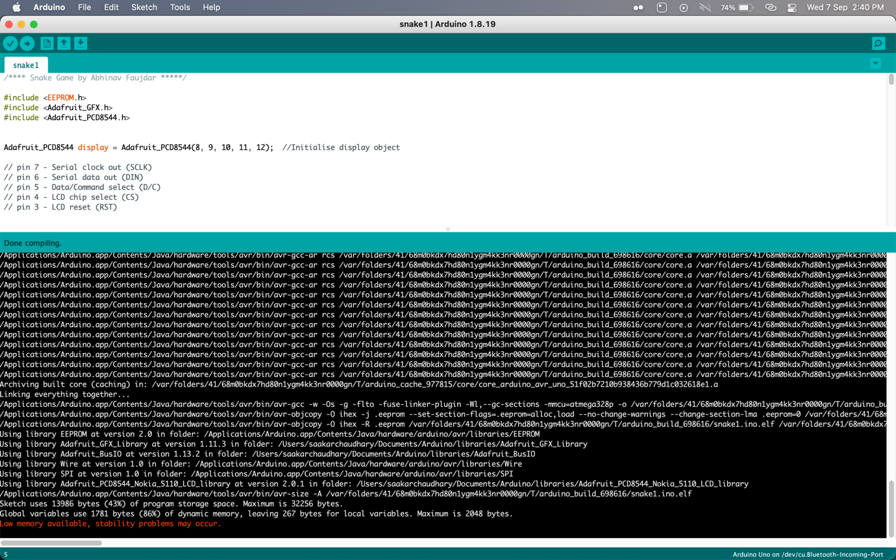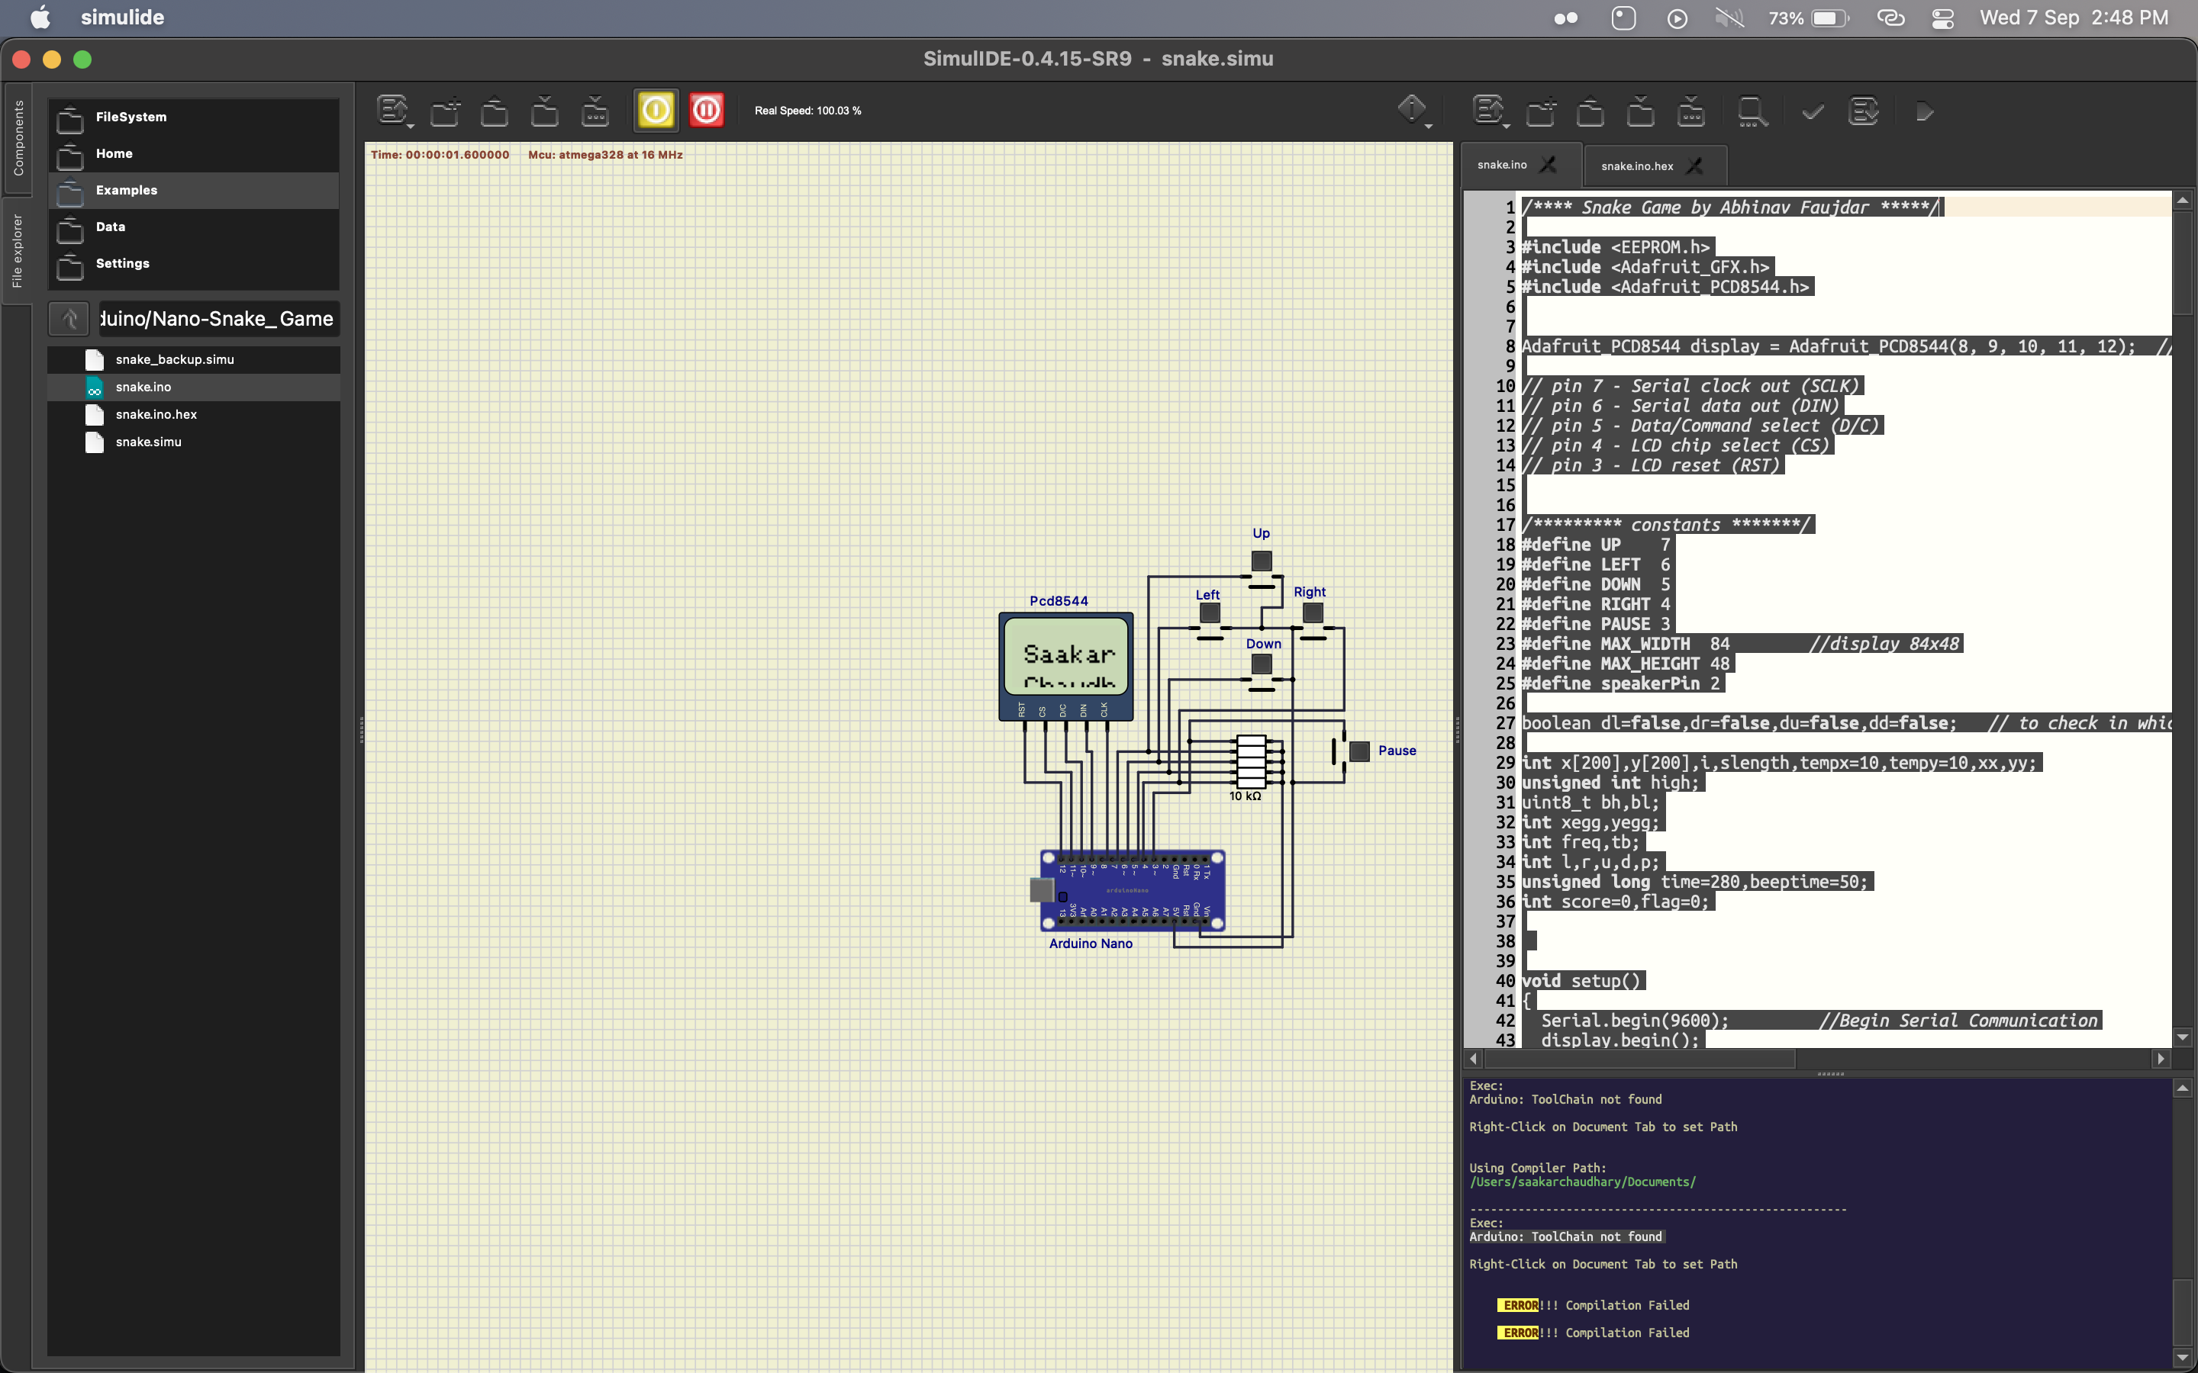

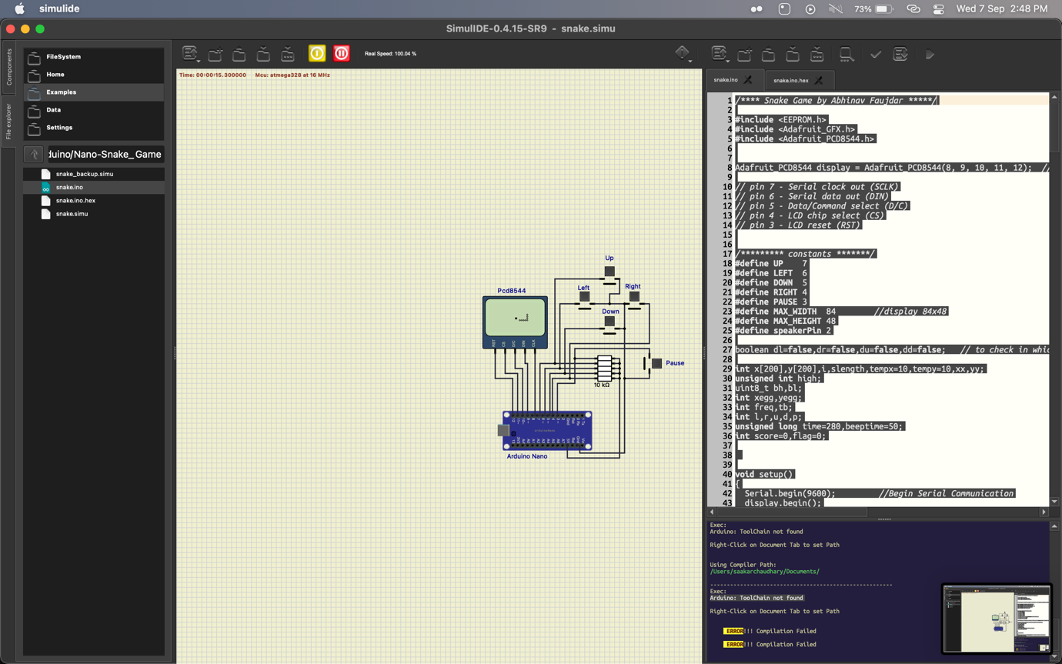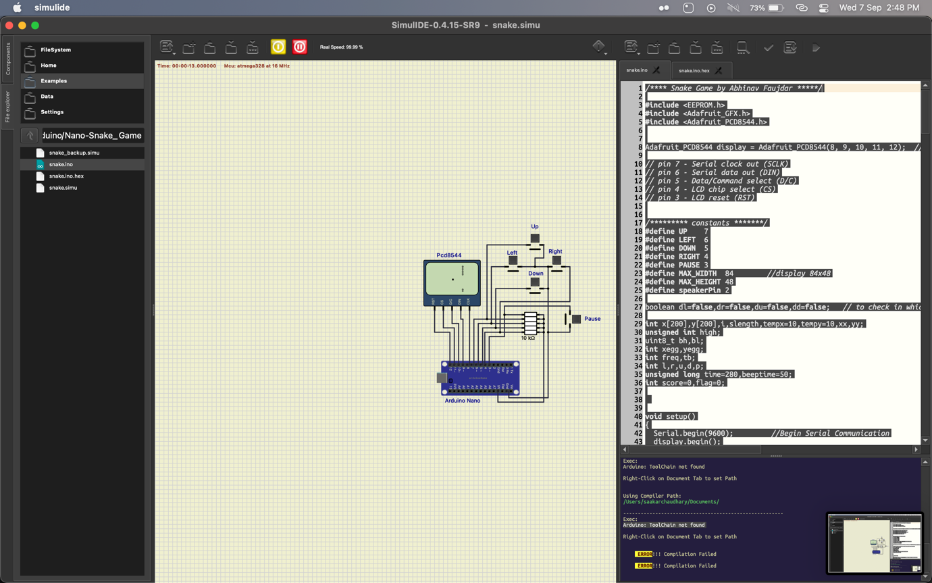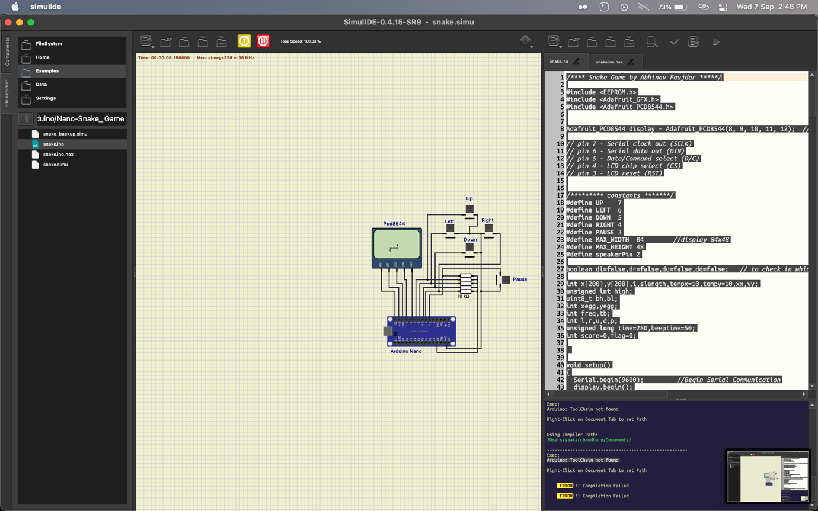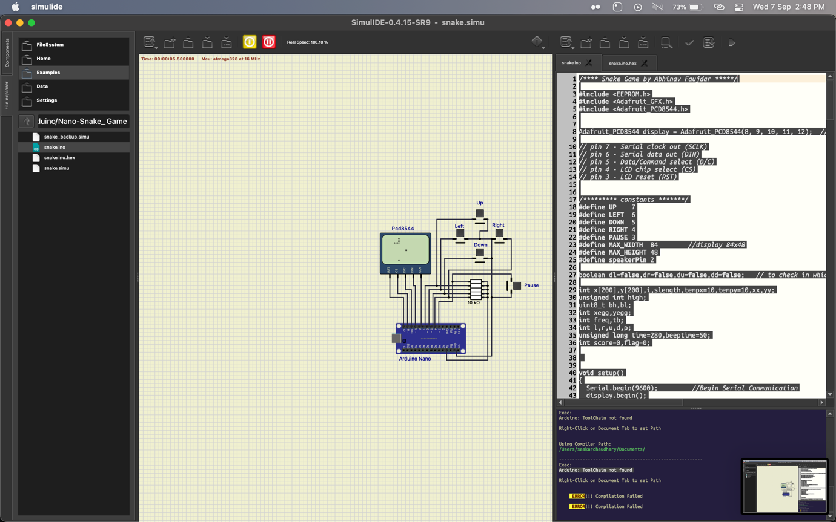

Conclusion:

Learned how to do basic error rectifying in Simulide

**Lab 6 B**

**Title: Marduino Game compilation using Arduino NANO in simul IDE.**

CODE:

#include <SPI.h>

#include <Adafruit_GFX.h>

#include <Adafruit_PCD8544.h>

#include "marduinotypes.h"

#include "tilemap.h"

#include "mariobitmap.h"

#include "levels.h"

Adafruit_PCD8544 display = Adafruit_PCD8544(8, 9, 10, 11, 12);

TileMap gameTilemap;

#define DELAY 75 // delay for fixed update interval

#define P_STILL 0

#define P_MOVE 1

#define P_JUMP 2

#define P_DEAD 3

#define GAME_INTRO 100

#define GAME_TITLE 101

#define GAME_CREDITS 102 #define GAME_LEVEL 103

#define GAME_PLAY 104

#define GAME_GAMEOVER 105

unsigned int gamestate = GAME_INTRO; // game state long TIMER_PREV = 0; // timer unsigned long TIMER_CURRENT = 0;

//mario img int const pimagew = 16; int const pimageh = 16; //marduino settings

int player_state = P_STILL; //player state int player_direction = 1;

int last_direction = 1; int life = 3; long playertimer = 0; long playertimer_prev = 0;

//posicao do mario

Vector2f player_position(0,display.height()-pimageh-8);

Vector2f player_position2(0,display.height()-pimageh-8);

Vector2f last_safe_position(0,display.height()-pimageh-8);

//horizontal speed vars float hspd = 0; float hspd_speed = 3.0; //jump vars and gravity control float grav = 0.6; float jumpspd = 4.0; float vspd = 0; boolean onAir = false; boolean check_pulo = false; //animation vars int frame = 0; int frameMax = 4; float frameSpd = 1; float frameCounter = 0; boolean animInit = false; //collision box offset

float pboxoffsetx = 3;

// camera control

Vector2f camera = {0,0}; Vector2f last_camera = {0,0};

int camera_player_side = 0;

float sign(float x) {

if (x > 0) return 1; else if (x < 0) return -1; return 0;

};

boolean buttonPressing[] = {false,false,false}; // button is pressing boolean buttonRelease[] = {false,false,false}; // button is released boolean buttonPressed[] = {false,false,false}; // button has pressed one time boolean buttonPressedCheck[] = {false,false,false};

boolean buttonReleaseCheck[] = {false,false,false};

void inputManager(unsigned int pin0, unsigned int pin1, unsigned int pin2) { //input manager in loop || gerenciador de inputs em loop int p[3];

p[0] = digitalRead(pin0);//LÃª o pino 5 p[1] = digitalRead(pin1);//LÃª o pino 6 p[2] = digitalRead(pin2);//LÃª o pino 7 for (int i = 0; i < 3; i++) { if (buttonPressed[i]) { // pressed ok buttonPressed[i] = false; buttonPressedCheck[i] = true;

}

if (buttonRelease[i]) { // release ok buttonRelease[i] = false; buttonReleaseCheck[i] = true;

} if (p[i] == LOW) { // arduino check buttonPressing[i] = true; // pressing button buttonRelease[i] = false; //turn release off buttonReleaseCheck[i] = false; if (!buttonPressedCheck[i]) buttonPressed[i] = true;

} else {

//turn off all buttonPressing[i] = false; buttonPressed[i] = false; buttonPressedCheck[i] = false; if (!buttonReleaseCheck[i]) //released button! buttonRelease[i] = true;

}

}

}

boolean intersectionRect(float * rect1, float * rect2) { if (rect1[0] < rect2[0] + rect2[2] && rect1[0] + rect1[2] > rect2[0]) { if (rect1[1] < rect2[1] + rect2[3] && rect1[3] + rect1[1] > rect2[1]) { return true;

} } return false;

}

void playerCollisionChecker(float hs, float vs) {

float playerRect[4] = {player_position.x+pboxoffsetx+hs+camera.x, player_position.y+vs,10,16};

for (int i = 0; i < CollisionMap0Size*4; i += 4) {

float rectTest[] = {pgm_read_word_near(&CollisionMap0[i]),

pgm_read_word_near(&CollisionMap0[i+1]), pgm_read_word_near(&CollisionMap0[i+2]), pgm_read_word_near(&CollisionMap0[i+3])}; if (intersectionRect(playerRect,rectTest)) { if (hs != 0) { hspd = (int)hspd;

player_position.x = (int)player_position.x; boolean corrector = false; while (!corrector) {

playerRect[0] = player_position.x+pboxoffsetx+camera.x+sign(hspd);

if (!intersectionRect(playerRect,rectTest)) player_position.x += sign(hspd); else

corrector = true;

} hspd = 0; break; } if (vs != 0) { vspd = (int)vspd;

player_position.y = (int)player_position.y; boolean correctorY = false; while (!correctorY) {

playerRect[1] = player_position.y+camera.y+sign(vspd);

if (!intersectionRect(playerRect,rectTest)) player_position.y += sign(vspd); else

correctorY = true;

} vspd = 0; check_pulo = false; break;

}

}

}

}

boolean verifyCollision(float * rect) {

for (int i = 0; i < CollisionMap0Size*4; i += 4) { float rectTest[4] = {pgm_read_word_near(&CollisionMap0[i]),

pgm_read_word_near(&CollisionMap0[i+1]), pgm_read_word_near(&CollisionMap0[i+2]), pgm_read_word_near(&CollisionMap0[i+3])}; if (intersectionRect(rect,rectTest)) { return true;

} }

return false;

}

void playerLogic(boolean move_esq, boolean move_dir, boolean jump) {

//HORIZONTAL MOVEMENT

if (player_state != P_DEAD) { hspd = 0; boolean moving = false;

if (move_esq == true && move_dir == false) {

player_direction = 1; moving = true;

} else if (move_dir == true && move_esq == false) {

player_direction = -1; moving = true;

} if (moving)

hspd = hspd_speed * (float)player_direction; playerCollisionChecker(hspd,0); player_position2.x += hspd; if (camera_player_side == -1) { if (player_position.x > (display.width()/2)-10)

camera_player_side = 0; else

player_position.x += hspd;

// screen limit < if (player_position.x < 0) { player_position.x = 0; hspd = 0;

}

} else if (camera_player_side == 1) { if (player_position.x < (display.width()/2)-10)

camera_player_side = 0; else

player_position.x += hspd;

// screen limit >

if (player_position.x > display.width()) { gamestate = GAME_TITLE;

/*player_position.x = display.width()-pimagew; hspd = 0;*/

} }

if (camera_player_side == 0) { //verify for limit side >

if (camera.x >= 0 && camera.x <= gameTilemap.getMapWidth()*8-display.width()) { camera.x += hspd;

} if (camera.x > gameTilemap.getMapWidth()*8-display.width()) { camera_player_side = 1;

camera.x = gameTilemap.getMapWidth()*8-display.width();

player_position.x += hspd;

} if (camera.x < 0) {

camera_player_side = -1; player_position.x += hspd; camera.x = 0;

}

}

//VERTICAL MOVEMENT

//gravidade (esta no ar) float playerRect[4] = {

camera.x+player_position.x+pboxoffsetx,camera.y+player_position.y+1, 10, 16 }; if (!verifyCollision(playerRect)) {

vspd += grav; check_pulo = true; onAir = true; } else { onAir = false;

}

// checa colisao com chao if (vspd != 0) {

playerCollisionChecker(0,vspd);

}

if (jump == true && check_pulo == false) { vspd -= jumpspd; check_pulo = true;

} player_position.y += vspd; player_position2.y += vspd; if (vspd == 0 && !onAir) { last_direction = player_direction; last_camera.x = camera.x; last_camera.y = player_position2.y; last_safe_position.x = player_position.x; last_safe_position.y = player_position.y;

}

//fall

if (player_position.y+camera.y > gameTilemap.getMapHeight()*gameTilemap.getTileHeight()) { if (player_state != P_DEAD)

player_state = P_DEAD;

}

if (player_state != P_DEAD) { if (hspd == 0 && vspd == 0) { if (player_state != P_STILL) { player_state = P_STILL; animInit = true;

}

} else if (hspd != 0 && vspd == 0) { if (player_state != P_MOVE) { player_state = P_MOVE; animInit = true;

} } if (vspd != 0) { if (player_state != P_JUMP) { player_state = P_JUMP; animInit = true;

}

}

}

} else {

playertimer++; // every DELAY | 1 = 75 millis

if (playertimer > 1000/75) { // 1 sec playertimer = 0; life--; if (life > 0) {

player_position.x = (int)((last_safe_position.x/8)*8);/*+(8*-last_direction);*/ player_position.y = (int)((last_safe_position.y/8)*8); player_position2.x = player_position.x;

camera.x = (int)((last_camera.x/8)*8);/*+(8*last_direction);*//*-(display.width()/2)-8;*/ camera.y = 0; player_state = P_STILL;

vspd = 0; hspd = 0; check_pulo = false;

} else {

gamestate = GAME_GAMEOVER;

}

}

}

}

void playerDraw() {

//BMP * frameAtual;

const unsigned char * frameAtual;

//animation setup if (animInit) { frame = 0; frameCounter = 0;

if (player_state == P_STILL || player_state == P_JUMP) { frameSpd = 0.; frameMax = 1;

} else if (player_state == P_MOVE) { frameSpd = 0.8;

frameMax = 4;

}

animInit = false;

}

//controlador de tempo de frames if (frameMax > 1) { frameCounter += frameSpd*DELAY; if (frameCounter > DELAY) { frame++; frameCounter = 0; if (frame > frameMax-1) { frame = 0;

}

}

}

//frames manager if (player_state == P_STILL) { if (player_direction == 1)

frameAtual = frameMario0; else

frameAtual = frameMario4; } else if (player_state == P_JUMP) {

if (player_direction == 1)

frameAtual = frameMario3; else

frameAtual = frameMario7; } else if (player_state == P_MOVE) {

if (player_direction == 1) { switch (frame) { case 0: frameAtual = frameMario1; break; case 1: frameAtual = frameMario0; break; case 2: frameAtual = frameMario2; break; case 3: frameAtual = frameMario0; break;

}

} else { switch (frame) { case 0: frameAtual = frameMario5; break; case 1: frameAtual = frameMario4; break; case 2: frameAtual = frameMario6; break; case 3: frameAtual = frameMario4; break;

}

} } display.drawBitmap(player_position.x, player_position.y, frameAtual, pimagew,pimageh,1);

// debug collision box

//display.fillRect(player_position.x+pboxoffsetx, player_position.y, 10, 16, BLACK);

}

void drawGui() {

String stringint = String(life,DEC); String string = String("x" + stringint); display.setTextSize(1);

display.setTextColor(BLACK,WHITE);

display.setCursor(0,0);

display.print(string);

}

void sceneIntro() { display.clearDisplay(); //clean screen float sizex = 13*6;

display.setTextSize(1); display.setTextColor(BLACK);

display.setCursor((display.width()-sizex)/2,display.height()/2-12); display.print("A119_Prasanna"); sizex = 8*6;

display.setCursor((display.width()-sizex)/2,display.height()/2-4); display.print("presents"); display.display();

TIMER_CURRENT = millis();

if (TIMER_CURRENT - TIMER_PREV > 2500) { TIMER_PREV = TIMER_CURRENT;

display.clearDisplay();

gamestate = GAME_TITLE;

}

}

void sceneTitle() {

// loop title screen

float sizex = 14*6;

int select = 0; int selectMax = 3; unsigned int triggerSelect = 0; unsigned int counter = 0; unsigned int counterMax = 0;

while (gamestate == GAME_TITLE) {

TIMER_CURRENT = millis();

if (TIMER_CURRENT - TIMER_PREV > DELAY) { TIMER_PREV = TIMER_CURRENT; inputManager(5,6,7); if (triggerSelect == 0) { if (buttonPressed[2]) { select++; if (select >= selectMax) select = 0;

} else if (buttonPressed[0]) {

select--; if (select < 0) select = selectMax-1; } if (buttonPressed[1]) { triggerSelect = 1; counterMax = 3;

}

}

String str = "test"; switch (select) {

case 0: {str = "<START GAME>"; sizex = 12*6; break;}; case 1: {str = "< CREDITS >"; sizex = 11*6; break;}; case 2: {str = "< EXIT GAME >"; sizex = 13*6; break;};

} display.clearDisplay();

display.drawBitmap(0, 0, gameLogo, 84, 24,1); display.setTextSize(1);

if (triggerSelect == 1) display.setTextColor(WHITE,BLACK);

else

display.setTextColor(BLACK); display.setCursor((display.width()-sizex)/2, 24+8);

display.print(str); display.display(); if (triggerSelect != 0) { if (counter > counterMax) { counter = 0; triggerSelect++; } else { counter++;

}

} } if (triggerSelect == 3) {

if (select == 0) {

gamestate = GAME_LEVEL;

} else if (select == 1) {

gamestate = GAME_CREDITS;

} else { triggerSelect = 0;

}

}

}

}

void sceneCredit() {

float sizex = 8*6;

int page = 0;

while (gamestate == GAME_CREDITS) { TIMER_CURRENT = millis();

if (TIMER_CURRENT - TIMER_PREV > DELAY) { TIMER_PREV = TIMER_CURRENT;

inputManager(5,6,7);

if (buttonPressed[2] || buttonPressed[1] || buttonPressed[0]) { page++; } sizex = 8*6; display.clearDisplay(); display.setTextSize(1); display.setTextColor(BLACK); display.setCursor((display.width()-sizex)/2,0);

if (page < 2) display.print("CREDITS:"); display.setCursor(0,8); if (page == 0) { display.println("Created by:"); display.println("Prasanna and Divyanshi.");

} else if (page == 1) {

display.println("Written in C with Arduino Uno."); sizex = 10*6;

display.setCursor((display.width()-sizex)/2,32); display.print("Sept,2022.");

} else {

gamestate = GAME_TITLE;

}

display.display();

}

}

}

void sceneLevel() {

float sizex = 7*6;

while (gamestate == GAME_LEVEL) { display.clearDisplay(); display.fillRect(0, 0, display.width(), display.height(), BLACK); display.setTextSize(1); display.setTextColor(WHITE,BLACK);

display.setCursor((display.width()-sizex)/2,(display.height()/2)-3);

display.print("LEVEL 1");

display.display();

TIMER_CURRENT = millis();

if (TIMER_CURRENT - TIMER_PREV > 2250) { TIMER_PREV = TIMER_CURRENT;

gamestate = GAME_PLAY;

}

}

}

void sceneGameOver() {

float sizex = 9*6;

while (gamestate == GAME_GAMEOVER) {

display.clearDisplay();

display.fillRect(0, 0, display.width(), display.height(), BLACK); display.setTextSize(1); display.setTextColor(WHITE,BLACK);

display.setCursor((display.width()-sizex)/2,(display.height()/2)-3);

display.print("GAME OVER"); display.display();

TIMER_CURRENT = millis();

if (TIMER_CURRENT - TIMER_PREV > 3000) { TIMER_PREV = TIMER_CURRENT;

gamestate = GAME_TITLE;

}

}

}

void resetGame() {

player_state = P_STILL; life = 3; player_direction = 1; player_position.x = 0;

player_position.y = display.height()-pimageh-8; vspd = 0; hspd = 0;

camera.x = 0; camera.y = 0; camera_player_side = -1;

check_pulo = false;

}

void sceneGame() {

resetGame();

while (gamestate == GAME_PLAY) { TIMER_CURRENT = millis();

if(TIMER_CURRENT - TIMER_PREV > DELAY) { // game loop

TIMER_PREV = TIMER_CURRENT;

inputManager(5,6,7); // 5 = 0

if (buttonPressing[2] && buttonPressing[1] && buttonPressing[0]) gamestate = GAME_TITLE;

playerLogic(buttonPressing[2],buttonPressing[0],buttonPressed[1]); display.clearDisplay(); gameTilemap.drawMap(camera.x,camera.y);

playerDraw(); drawGui(); display.display();

}

}

}

void setup() {

Serial.begin(9600);

display.begin();

// init done

// you can change the contrast around to adapt the display // for the best viewing! display.setContrast(50);

//song - DOSENT WORK - DO NOT USE

//pinMode(3, OUTPUT);//buzzer

//pinMode(13, OUTPUT);//led indicator when singing a note

// inputs

pinMode(7, INPUT);//Define o pino 7 como entrada digitalWrite(7, HIGH);//Ativa o resistor de pull-up da porta 7 pinMode(6, INPUT);//Define o pino 7 como entrada digitalWrite(6, HIGH);//Ativa o resistor de pull-up da porta 7 pinMode(5, INPUT);//Define o pino 7 como entrada

digitalWrite(5, HIGH);//Ativa o resistor de pull-up da porta 7

gameTilemap.setMapSize(100,6); gameTilemap.setDisplayPointer(&display);

gameTilemap.setTileMap(TileMap0);

};

void loop() {

switch (gamestate) { // "STATE MACHINE MANAGER" case GAME_INTRO: {sceneIntro(); break;} case GAME_TITLE: {sceneTitle(); break;} case GAME_CREDITS: {sceneCredit(); break;} case GAME_LEVEL: {sceneLevel(); break;} case GAME_PLAY: {sceneGame(); break;}

case GAME_GAMEOVER: {sceneGameOver(); break;}

}

}

OUTPUT:

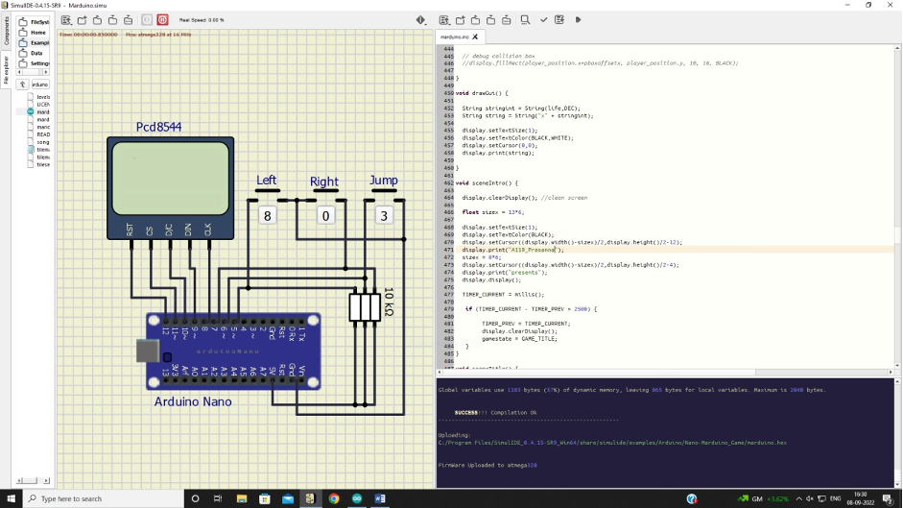

**Lab 8**

**Title: Snake Game compilation using Arduino NANO in simul IDE**

CODE:

#include <EEPROM.h>

#include <Adafruit_GFX.h>

#include <Adafruit_PCD8544.h>

Adafruit_PCD8544 display = Adafruit_PCD8544(8, 9, 10, 11, 12);

#define UP 7

#define LEFT 6

#define DOWN 5

#define RIGHT 4

#define PAUSE 3

#define MAX_WIDTH 84

#define MAX_HEIGHT 48

#define speakerPin 2

boolean dl=false,dr=false,du=false,dd=false; // to check in which direction the snake is currently moving

int x[200],y[200],i,slength,tempx=10,tempy=10,xx,yy; unsigned int high; uint8_t bh,bl; int xegg,yegg; int freq,tb;

int l,r,u,d,p;

unsigned long time=280,beeptime=50;

int score=0,flag=0;

void setup()

{

Serial.begin(9600); //Begin Serial Communication display.begin(); display.clearDisplay();

pinMode(LEFT,INPUT); //Directional keys and pause

pinMode(RIGHT,INPUT); pinMode(UP,INPUT); pinMode(DOWN,INPUT); pinMode(PAUSE,INPUT);

pinMode(speakerPin,OUTPUT); //Buzzer pin digitalWrite(LEFT,HIGH); //Active low keys digitalWrite(RIGHT,HIGH); digitalWrite(UP,HIGH); digitalWrite(DOWN,HIGH); digitalWrite(PAUSE,HIGH); display.setContrast(25); slength=8; //Start with snake length 8 xegg=(display.width())/2; yegg=(display.height())/2; display.setTextSize(1); //Initial Display display.setTextColor(BLACK); display.setCursor(10,15); display.print("Prasanna"); display.setCursor(10,40); display.print("A119"); display.display(); delay(4000); display.clearDisplay();

for(i=0;i<=slength;i++) //Set starting coordinates of snake

{ x[i]=25-3*i; y[i]=10; }

for(i=0;i<slength;i++) //Draw the snake

{

display.drawCircle(x[i],y[i],1,BLACK);

}

display.display();

dr=true; //Going to move right initially

}

//Movement Begins after here

void loop()

{ movesnake(); //This is called endlessly

}

void movesnake()

{ l=digitalRead(LEFT); //Continuously Check the Keys

d=digitalRead(DOWN); r=digitalRead(RIGHT); u=digitalRead(UP);

p=digitalRead(PAUSE);

if(flag==0)

{

direct(); //When key is pressed,this will change the coordinates accordingly and set flag to 1 //flag would be set to 1 so that direction is not changed multiple times in a short duration }

if(millis()%time==0) //this condition becomes true after every 'time' milliseconds...millis() returns the time since launch of program

{

if(flag==0) //flag 0 means no directional key has been pressed in the last 'time' milliseconds

{

if(dr==true){tempx=x[0]+3;tempy=y[0];} // so the snake moves one step in the direction it is moving currently

if(dl==true){tempx=x[0]-3;tempy=y[0];} //The new coordinates of head of snake goes in tempx,tempy if(du==true){tempy=y[0]-3;tempx=x[0];}

if(dd==true){tempy=y[0]+3;tempx=x[0];}

} flag=0;

checkgame(); //Check if snake has met egg or coincided with itself checkegg();

if(tempx<=0){tempx=84+tempx;} //If the new coordinates are out of screen, set them accordingly if(tempx>=84){tempx=tempx-84;} if(tempy<=0){tempy=48+tempy;}

if(tempy>=48){tempy=tempy-48;}

for(i=0;i<=slength;i++) //Change the coordinates of all points of snake

{ xx=x[i]; yy=y[i]; x[i]=tempx; y[i]=tempy; tempx=xx; tempy=yy;

} drawsnake(); //Draw the snake and egg at the new coordinates }

}

void checkgame() //Game over checker

{

for(i=1;i<slength;i++) //Checking if the coordinates of head have become equal to one of the non head points of snake

{

if(x[i]==x[0] && y[i]==y[0])

{

bh=EEPROM.read(1); bl=EEPROM.read(0); high=(((0xff00+bh)<<8) + bl); if(score>high)

{ high=score; bh=(high >> 8); bl=high & 0xff;

EEPROM.write(1,bh);

EEPROM.write(0,bl);

}

display.clearDisplay(); display.setTextColor(BLACK); display.setTextSize(1); display.setCursor(20,12); display.print("Game Over"); display.setCursor(15,30); display.print("Score: "); display.print(score); display.setCursor(15,40); display.print("High: "); display.print(high); display.display(); beep(20,5000); display.clearDisplay(); slength=8; //Resetting the values score=0; time=280;

redraw(); //Restart game by drawing snake with the resetted length and score

}

}

}

void checkegg() //Snake meets egg

{

if(x[0]==xegg or x[0]==(xegg+1) or x[0]==(xegg+2) or x[0]==(xegg-1)) //Snake in close vicinity of egg

{

if(y[0]==yegg or y[0]==(yegg+1) or y[0]==(yegg+2) or y[0]==(yegg-1))

{

score+=1; //Increase length,score and increase movement speed by decreasing 'time' slength+=1; if(time>=90) {time-=20;}

display.fillRect(xegg,yegg,3,3,WHITE); //Delete the consumed egg display.display();

beep(35,beeptime); //Beep with a sound of 35Hz for 'beeptime' ms

xegg=random(1,80); //Create New egg randomly yegg=random(1,40);

}

} }

void direct() //Check if user pressed any keys and change direction if so

{

if(l==LOW and dr==false) //when key LEFT is pressed ,L will become low

{

dl=true;du=false;dd=false;

tempx=x[0]-3; //Save the new coordinates of head in tempx,tempy tempy=y[0];

flag=1; //Do not change direction any further for the ongoing 'time' milliseconds

}

else if(r==LOW and dl==false)

{

dr=true;du=false;dd=false; tempx=x[0]+3; tempy=y[0];

flag=1;

}

else if(u==LOW and dd==false)

{

du=true;dl=false;dr=false; tempy=y[0]-3; tempx=x[0];

flag=1;

}

else if(d==LOW and du==false)

{

dd=true;dl=false;dr=false; tempy=y[0]+3; tempx=x[0];

flag=1;

}

else if(p==LOW) //Pause game for 5 seconds

{ display.clearDisplay(); display.setTextColor(BLACK); for(i=5;i>0;i--)

{

display.setCursor(25,10); display.setTextSize(1); display.print("PAUSED"); display.setCursor(40,30); display.print(i); display.display(); delay(1000); display.clearDisplay();

}

redraw(); //Redraw the snake and egg at the same position as it was }

}

void drawsnake() //Draw snake and egg at newly changed positions

{

display.fillRect(xegg,yegg,3,3,BLACK); //Draw egg at new pos display.drawCircle(x[0],y[0],1,BLACK); //Draw new head of snake display.drawCircle(x[slength],y[slength],1,WHITE); //Delete old tail of snake display.display();

}

void redraw() //Redraw ALL POINTS of snake and egg

{

display.fillRect(xegg,yegg,3,3,BLACK);

for(i=0;i<slength;i++)

{

display.drawCircle(x[i],y[i],1,BLACK);

}

display.display();

}

void beep (int freq,long tb) //This function creates a sound of frequency 'freq' Hz and for a duration of 'tb' milliseconds

{ int x;

long delayAmount = (long)(500/freq); //Calculate time duration of half cycle long loopTime = (long)(tb/(delayAmount*2)); //Calculate no. of cycles for (x=0;x<loopTime;x++) // One iteration produces sound for one cycle

{

digitalWrite(speakerPin,HIGH); //High for half cycle delay(delayAmount);

digitalWrite(speakerPin,LOW); //Low for half cycle delay(delayAmount);

} delay(2);

//a little delay to make all notes sound separate

}

OUTPUT:

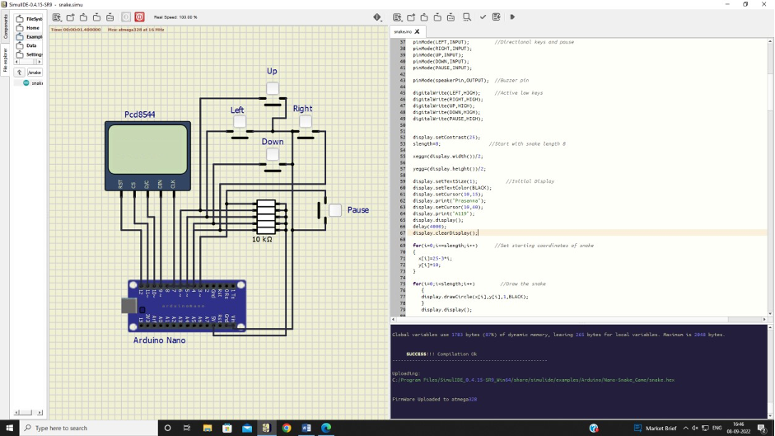

**LAB-7**

**Title: Traffic Lights system with Arduino and SimulIDE**

**Aim:**

To configure Traffic Lights RTOS with Arduino and SimulIDE.

**Apparatus:**

**Hardware Components used:**

1. Arduino UNO (atmega328 processor)
2. LED Lights: Red, Yellow and Green
3. 7 Resistors of 100 ohm each
4. 7 SEGMENT LED Display
5. 16x2 LCD Display Hd44780

**Software Used:**

1. SimulIDE
2. Arduino

**Theory:**

Traffic light RTOS creates a system to automatically change LED blinking when timer goes to zero. The circuit works on a single junction traffic light system with timer, LED lights and LED display which shows direction (‘Wait,’ ‘Stop,’ ‘Go’).

**Procedure:**

**Hardware Configuration procedure:**

1. Open SimulIDE.exe
2. Create a new simulation named as traffic.simu
3. Make connections as follows:

|  |  |
| --- | --- |
| Component | Connections to Arduino UNO and ground |
| 7 Segment LED | A-G pins of 7 Segment to Arduino UNO pins with 100-ohm resistor in series: A to 2 |
|  | * B to 3 * C to 4 * D to 5 * E to 6 * F to 7 * G to 1   Connect the left pin to 5V in Arduino UNO and Right pin to Gnd |
| LCD Display | LCD Display pins to Arduino UNO pins   * RS to 13 * RW to Ground * EN to 12 * D4 to 11 * D5 to 10 * D6 to 9 * D7 to 8 |
| Red Led | LED pins to Arduino UNO  Anode to A1  Cathode to Ground |
| Yellow LED | LED pins to Arduino UNO  Anode to A2  Cathode to Ground |
| Green LED | LED pins to Arduino UNO  Anode to A3  Cathode to Ground |

**Software Configuration Procedure:**

1. Create a new Arduino program and save it as traffic.ino.
2. Type the program in SimulIDE and save it.
3. Set the compiler path to Arduino and wait until message “compilation is successful” is displayed.
4. Upload the firmware in Arduino and run the setup using the power button in the simulation tab.

**Circuit Setup:**

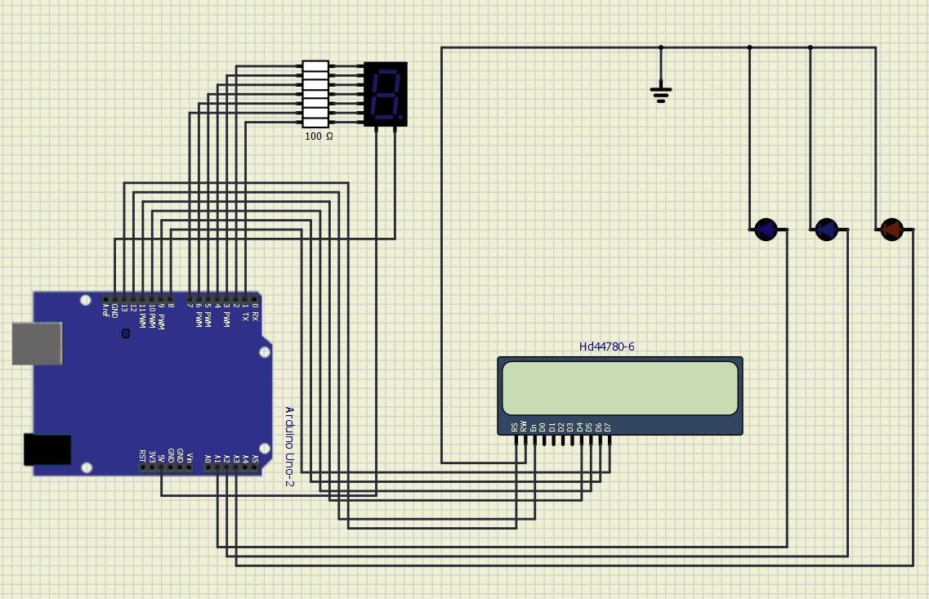

**Code:**

#include <LiquidCrystal.h>

LiquidCrystal mylcd(13,12,11,10,9,8); int a=2,b=3,c=4,d=5,e=6,f=7,g=1; int COUNT; int red=A1,yellow=A2,green=A3;

void setup()

{

pinMode(red,OUTPUT); pinMode(yellow,OUTPUT); pinMode(green,OUTPUT); pinMode(a,OUTPUT); pinMode(b,OUTPUT); pinMode(c,OUTPUT); pinMode(d,OUTPUT); pinMode(e,OUTPUT); pinMode(f,OUTPUT); pinMode(g,OUTPUT); mylcd.begin(16,2); mylcd.home(); }

void loop() { analogWrite(red,0); analogWrite(yellow,0);

analogWrite(green,0);

mylcd.clear(); analogWrite(yellow,255); mylcd.print("Wait");

timer(3);

mylcd.clear(); analogWrite(yellow,0); analogWrite(red,255); mylcd.print("Stop");

timer(5);

mylcd.clear(); analogWrite(red,0); analogWrite(yellow,255); mylcd.print("Wait");

timer(3);

mylcd.clear(); analogWrite(yellow,0); analogWrite(green,255);

mylcd.print("Go"); timer(5);

}

void timer(int nu)

{

for(COUNT=nu;COUNT>=0;COUNT--)

{

Serial.begin(9600); Serial.println(COUNT);

switch (COUNT)

{

case 0://when count value is zero show”0” on disp

digitalWrite(a, HIGH);

digitalWrite(b, HIGH); digitalWrite(c, HIGH); digitalWrite(d, HIGH); digitalWrite(e, HIGH); digitalWrite(f, HIGH); digitalWrite(g, LOW); delay(1000); break;

case 1:// when count value is 1 show”1” on disp digitalWrite(a, LOW); digitalWrite(b, HIGH); digitalWrite(c, HIGH); digitalWrite(d, LOW); digitalWrite(e, LOW); digitalWrite(f, LOW); digitalWrite(g, LOW); delay(1000); break;

case 2:// when count value is 2 show”2” on disp digitalWrite(a, HIGH); digitalWrite(b, HIGH); digitalWrite(c, LOW); digitalWrite(d, HIGH); digitalWrite(e, HIGH); digitalWrite(f, LOW); digitalWrite(g, HIGH); delay(1000); break;

case 3:// when count value is 3 show”3” on disp digitalWrite(a, HIGH); digitalWrite(b, HIGH); digitalWrite(c, HIGH); digitalWrite(d, HIGH); digitalWrite(e, LOW); digitalWrite(f, LOW); digitalWrite(g, HIGH); delay(1000); break;

case 4:// when count value is 4 show”4” on disp digitalWrite(a, LOW); digitalWrite(b, HIGH); digitalWrite(c, HIGH); digitalWrite(d, LOW); digitalWrite(e, LOW); digitalWrite(f, HIGH);

digitalWrite(g, HIGH);

delay(1000); break;

case 5:// when count value is 5 show”5” on disp digitalWrite(a, HIGH); digitalWrite(b, LOW); digitalWrite(c, HIGH); digitalWrite(d, HIGH); digitalWrite(e, LOW); digitalWrite(f, HIGH); digitalWrite(g, HIGH);

delay(1000);

break; }

}

}

**Observations:**

1. After opening SimulIDE software, the components such as the LED lights, 7 Segment LED, LCD Display, resistors and Arduino UNO were placed on the simulation panel.
2. After making the relevant connections as per the setup given above, the file was saved as traffic.simu.
3. Then, the code was written and executed in Arduino Software where the pins on the 7-segment display was configured to make it display numerical output
4. The code was then saved as traffic.ino and compiled in SimulIDE
5. It was then compiled successfully and uploaded to atmega328 (Arduino’s microprocessor).
6. On running the simulation, the LED lights were blinking in real time with respect to countdown of seconds from 7 Segment display.
7. The value of resistor was too high with 1 Kilo Ohm, so the value of resistance was changed to 100 Ohm to get clearer intensity of light from LED.
8. We used Hd44780 by Hitachi which is a 16 x 2 LCD. It uses Dot matrix method.

**Screenshots:**

1. Setup of the circuit:

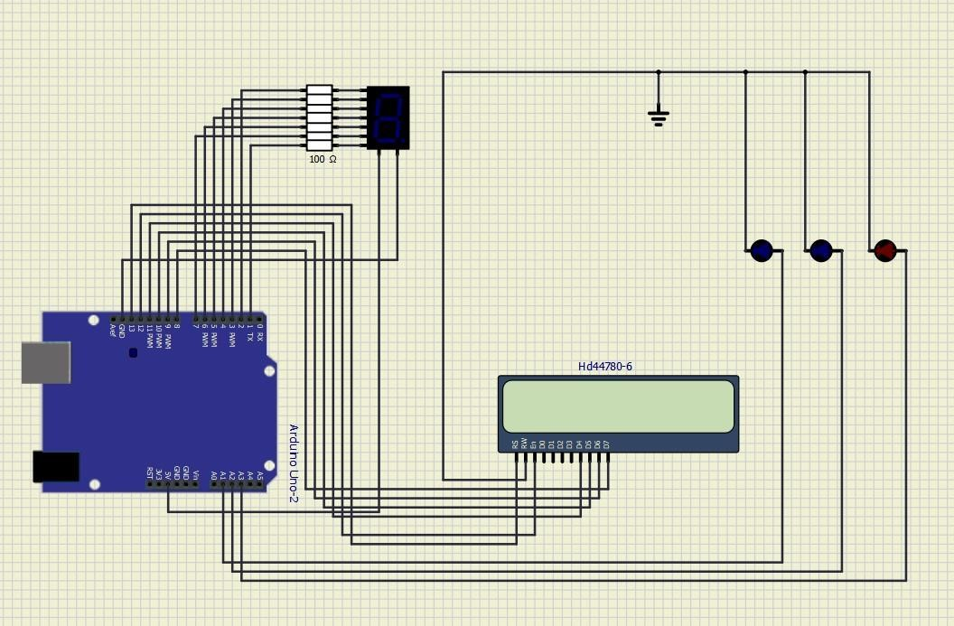

1. Changing the colour of LEDs:

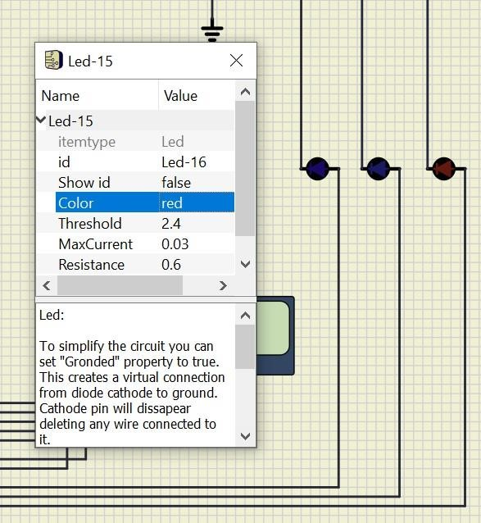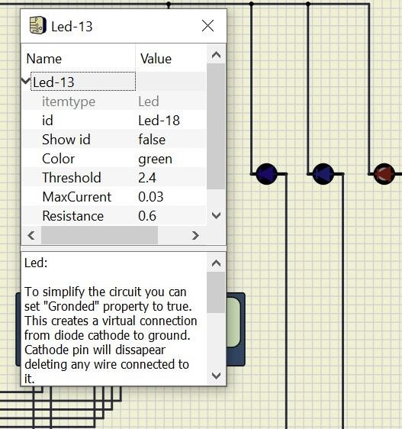

1. Changing the resistance values:

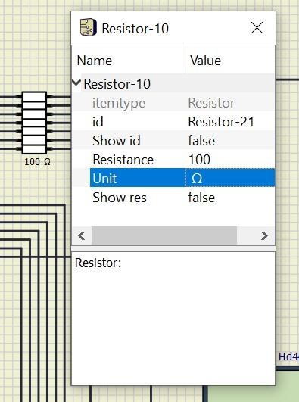

Code For 4 Way:

int Lane1[] = {13,12,11}; // Lane 1 Red, Yellow and Green

int Lane2[] = {10,9,8};// Lane 2 Red, Yellow and Green

int Lane3[] = {7,6,5};// Lane 3 Red, Yellow and Green

int Lane4[] = {4,3,2};// Lane 4 Red, Yellow and Green

void setup()

{

for (int i = 0; i < 3; i++)

{

pinMode(Lane1[i], OUTPUT);

pinMode(Lane2[i], OUTPUT);

pinMode(Lane3[i], OUTPUT);

pinMode(Lane4[i], OUTPUT);

}

for (int i = 0; i < 3; i++)

{

digitalWrite(Lane1[i], LOW);

digitalWrite(Lane2[i], LOW);

digitalWrite(Lane3[i], LOW);

digitalWrite(Lane4[i], LOW);

}

}

void loop()

{

digitalWrite(Lane1[2], HIGH);

digitalWrite(Lane3[0], HIGH);

digitalWrite(Lane4[0], HIGH);

digitalWrite(Lane2[0], HIGH);

delay(7000);

digitalWrite(Lane1[2], LOW);

digitalWrite(Lane3[0], LOW);

digitalWrite(Lane1[1], HIGH);

digitalWrite(Lane3[1], HIGH);

delay(3000);

digitalWrite(Lane1[1], LOW);

digitalWrite(Lane3[1], LOW);

digitalWrite(Lane1[0], HIGH);

digitalWrite(Lane3[2], HIGH);

delay(7000);

digitalWrite(Lane3[2], LOW);

digitalWrite(Lane4[0], LOW);

digitalWrite(Lane3[1], HIGH);

digitalWrite(Lane4[1], HIGH);

delay(3000);

digitalWrite(Lane3[1], LOW);

digitalWrite(Lane4[1], LOW);

digitalWrite(Lane3[0], HIGH);

digitalWrite(Lane4[2], HIGH);

delay(7000);

digitalWrite(Lane4[2], LOW);

digitalWrite(Lane2[0], LOW);

digitalWrite(Lane4[1], HIGH);

digitalWrite(Lane2[1], HIGH);

delay(3000);

digitalWrite(Lane4[1], LOW);

digitalWrite(Lane2[1], LOW);

digitalWrite(Lane4[0], HIGH);

digitalWrite(Lane2[2], HIGH);

delay(7000);

digitalWrite(Lane1[0], LOW);

digitalWrite(Lane2[2], LOW);

digitalWrite(Lane1[1], HIGH);

digitalWrite(Lane2[1], HIGH);

delay(3000);

digitalWrite(Lane2[1], LOW);

digitalWrite(Lane1[1], LOW);

}

Circuit 4 way:

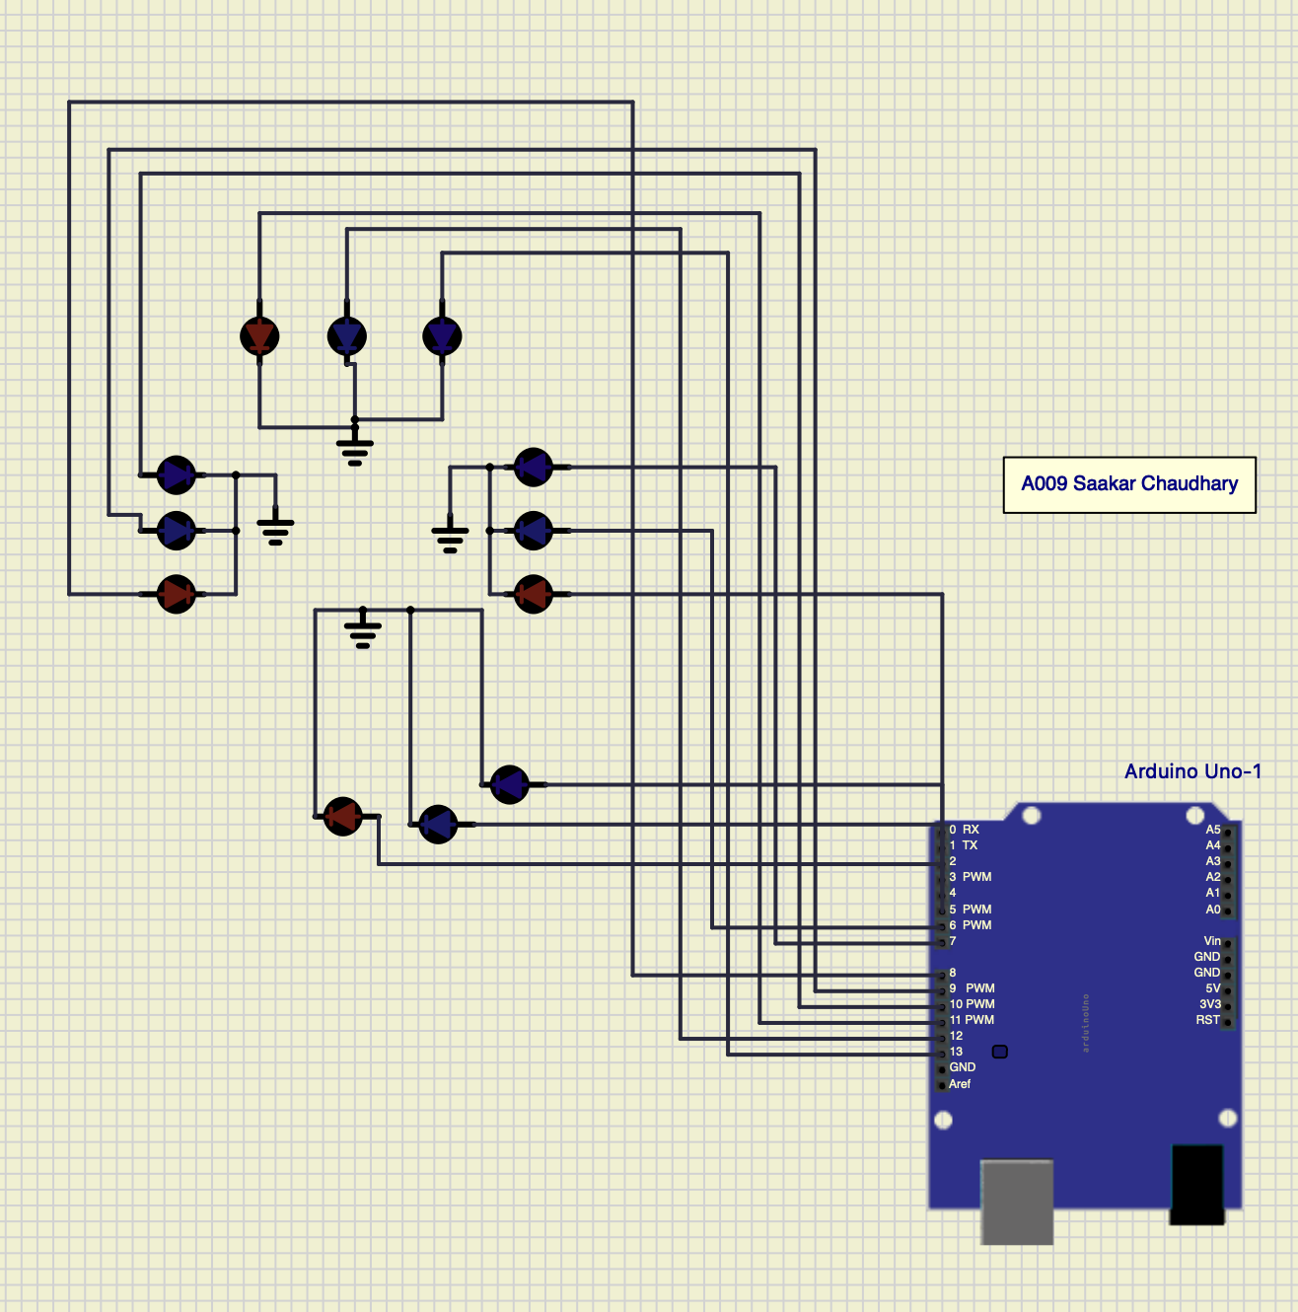

Output For 4 Way:

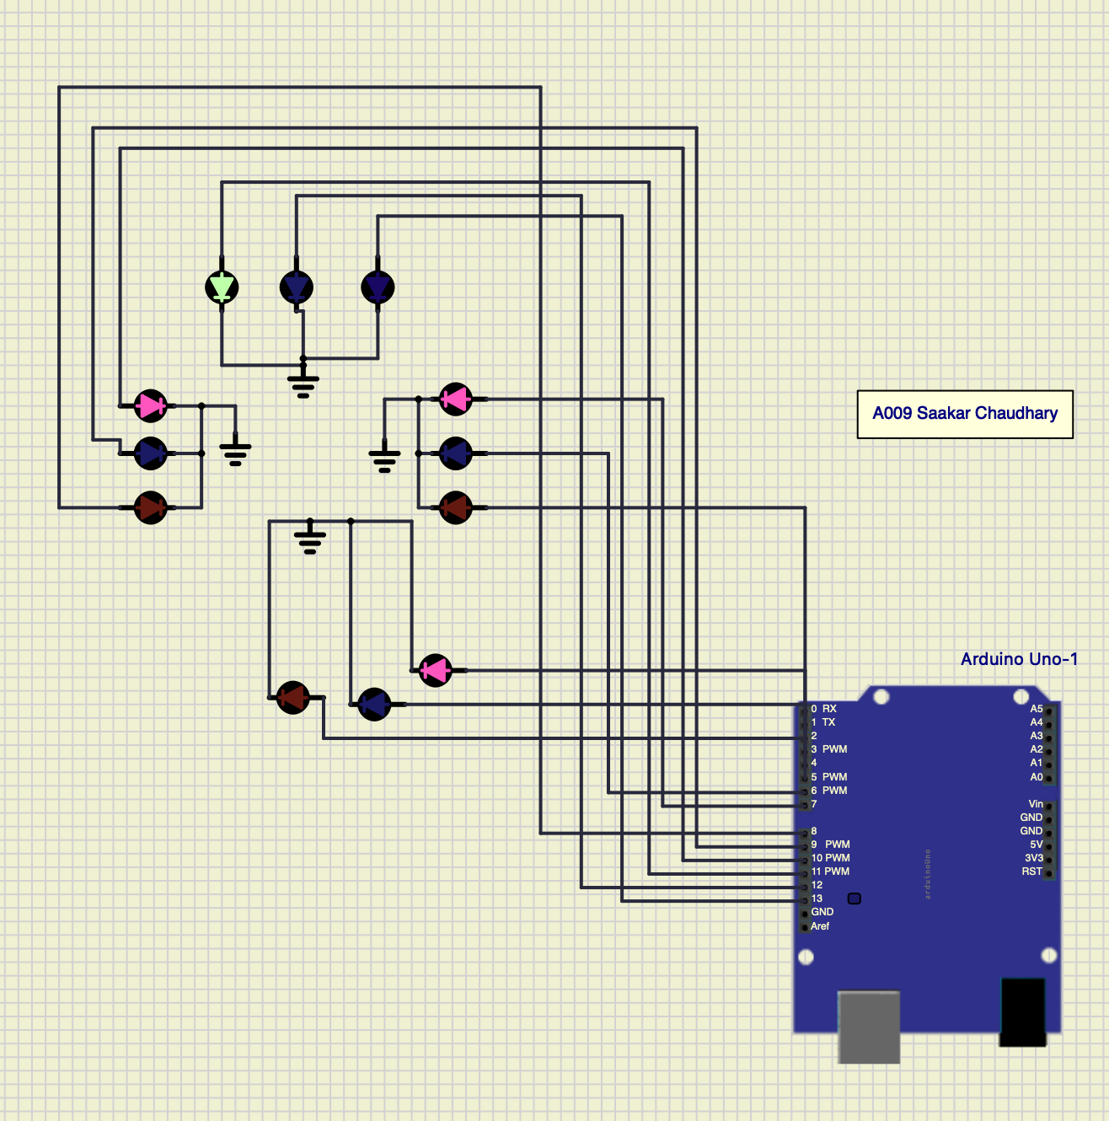

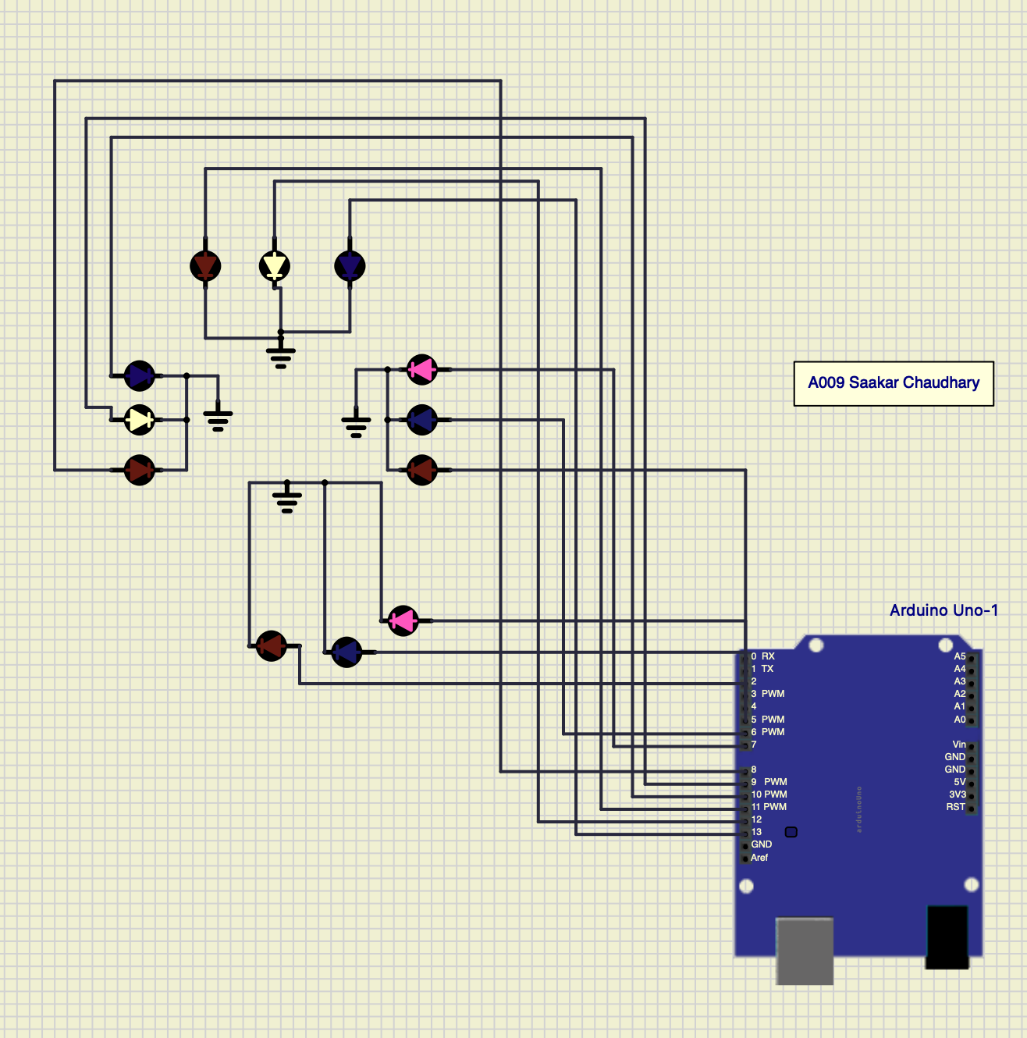

Conclusion: Learned how traffic light system works and trying to make a 4 way traffic lights system.

**Lab 8**

**Title: Round Robin scheduling algorithm**

Aim: Round Robin scheduling using virtual lab and program execution.

Theory:

Round Robin Scheduling Policy

The operating system has many processes in memory and running simultaneously. Each process has its own burst time (execution time). There are other processes which are ready for execution and waiting for allocation of CPU. The processes waiting for allocation of CPU are kept in READY QUEUE in the sequence according to their arrival for execution. The time at which the process arrives is called ARRIVAL TIME. The CPU has to apply fair scheduling policy so that no process is favored and no process is deprived of execution.

Round Robin is the preemptive process scheduling algorithm policy which allocates CPU to the processes as per defined time quantum. Once the time quantum is over, the process goes in waiting state and is added at the end of the READY QUEUE. The process waits for the turn again.

The ready queue maintains the list of the processes and the sequence in which the CPU must be allocated. When the processes complete their execution, they go out of memory of operating system.

Keywords:

**Arrival Time:** Time when the process arrives for execution.

**Completion Time:** Time when process completes its execution.

**Burst Time(Execution Time):** Time required by the process once submitted to CPU.

**Turn Around Time:** Time Difference between completion time and arrival time.

**{ Turn Around Time = Completion Time – Arrival Time }**

**Waiting Time:** Time Difference between turn around time and burst time.

**{ Waiting Time = Turn Around Time – Burst Time }**

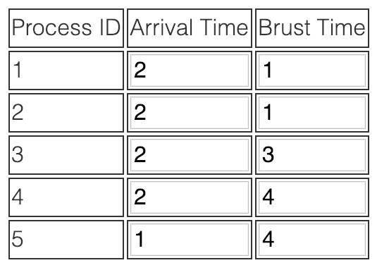

Calculation:

Reference :[Virtual Labs (iitb.ac.in)](http://vlabs.iitb.ac.in/vlabs-dev/vlab_bootcamp/bootcamp/CRUX/labs/exp1/index.html)

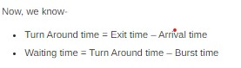

|  |  |  |  |
| --- | --- | --- | --- |
| Process ID | EXIT Time | Turn around time | Waiting time |
| 1 |  | 1 | 0 |
| 2 |  | 2 | 1 |
| 3 |  | 5 | 2 |
| 4 |  | 12 | 8 |
| 5 |  | 13 | 9 |

Also using some code you can verify the values of the above

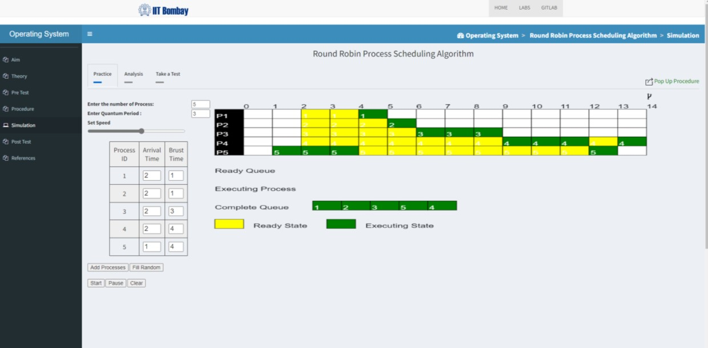

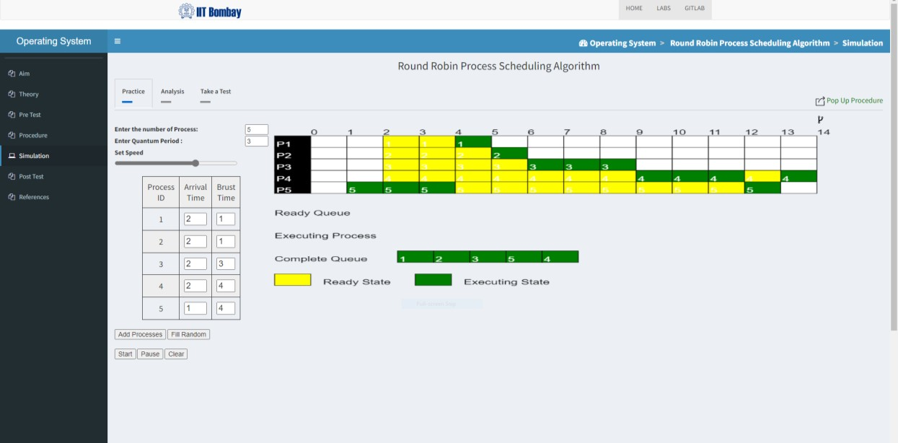

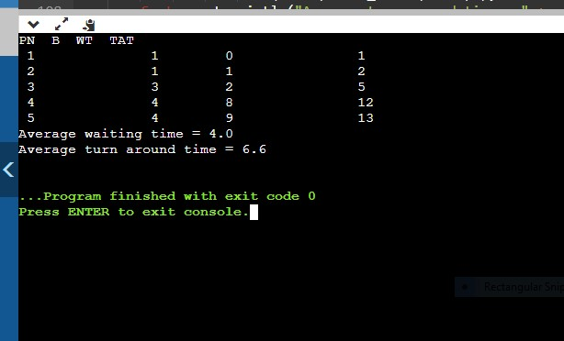

LAB-9.8051 MICRO CONTROLLER SIMULATION

Aim

Interfacing of 8051 Microcontroller with various display devices

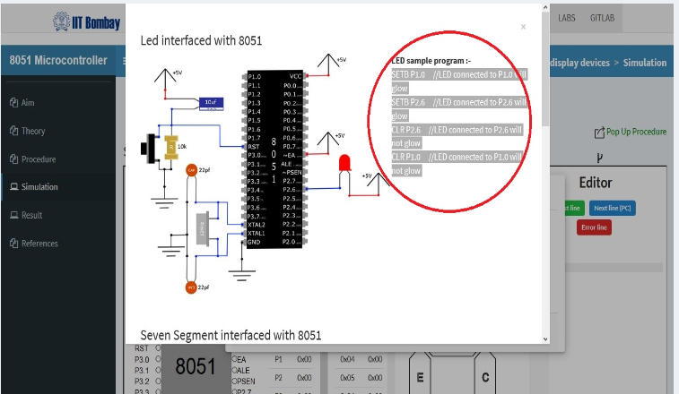

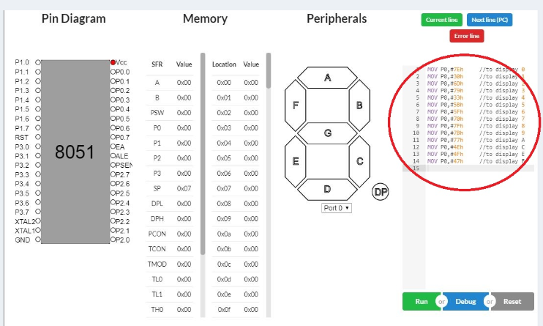

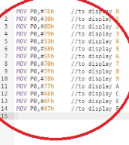

**MOV P0,#7EH**

**MOV P0,#30H**

**MOV P0,#60H**

**MOV P0,#79H**

**MOV P0,#33H**

**MOV P0,#5BH**

**MOV P0,#5FH**

**MOV P0,#70H**

**MOV P0,#7FH**

**MOV P0,#7BH**

**MOV P0,#77H**

**MOV P0,#4EH**

**MOV P0,#47H**

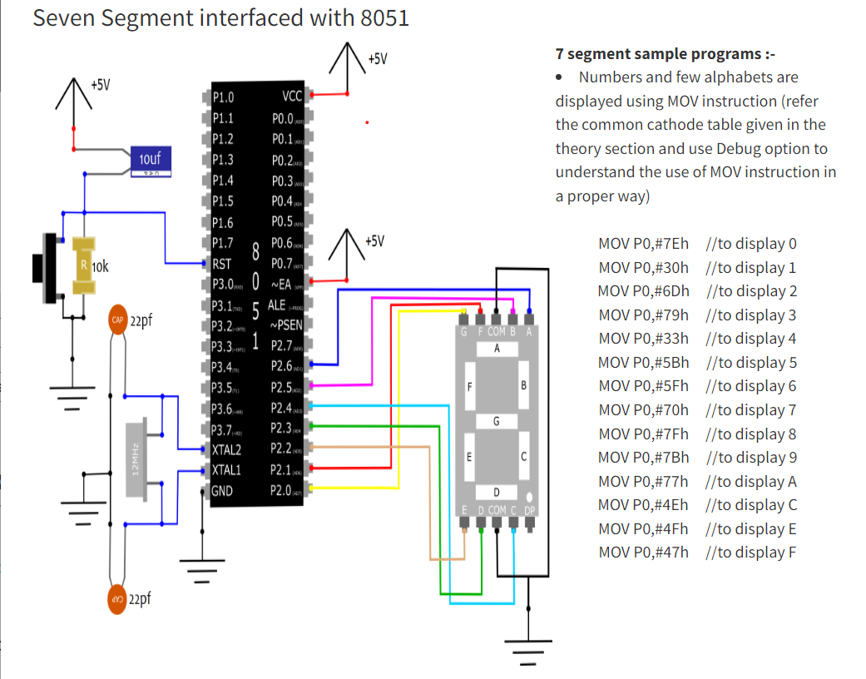

**Output:**

Configuration to display letters and numbers

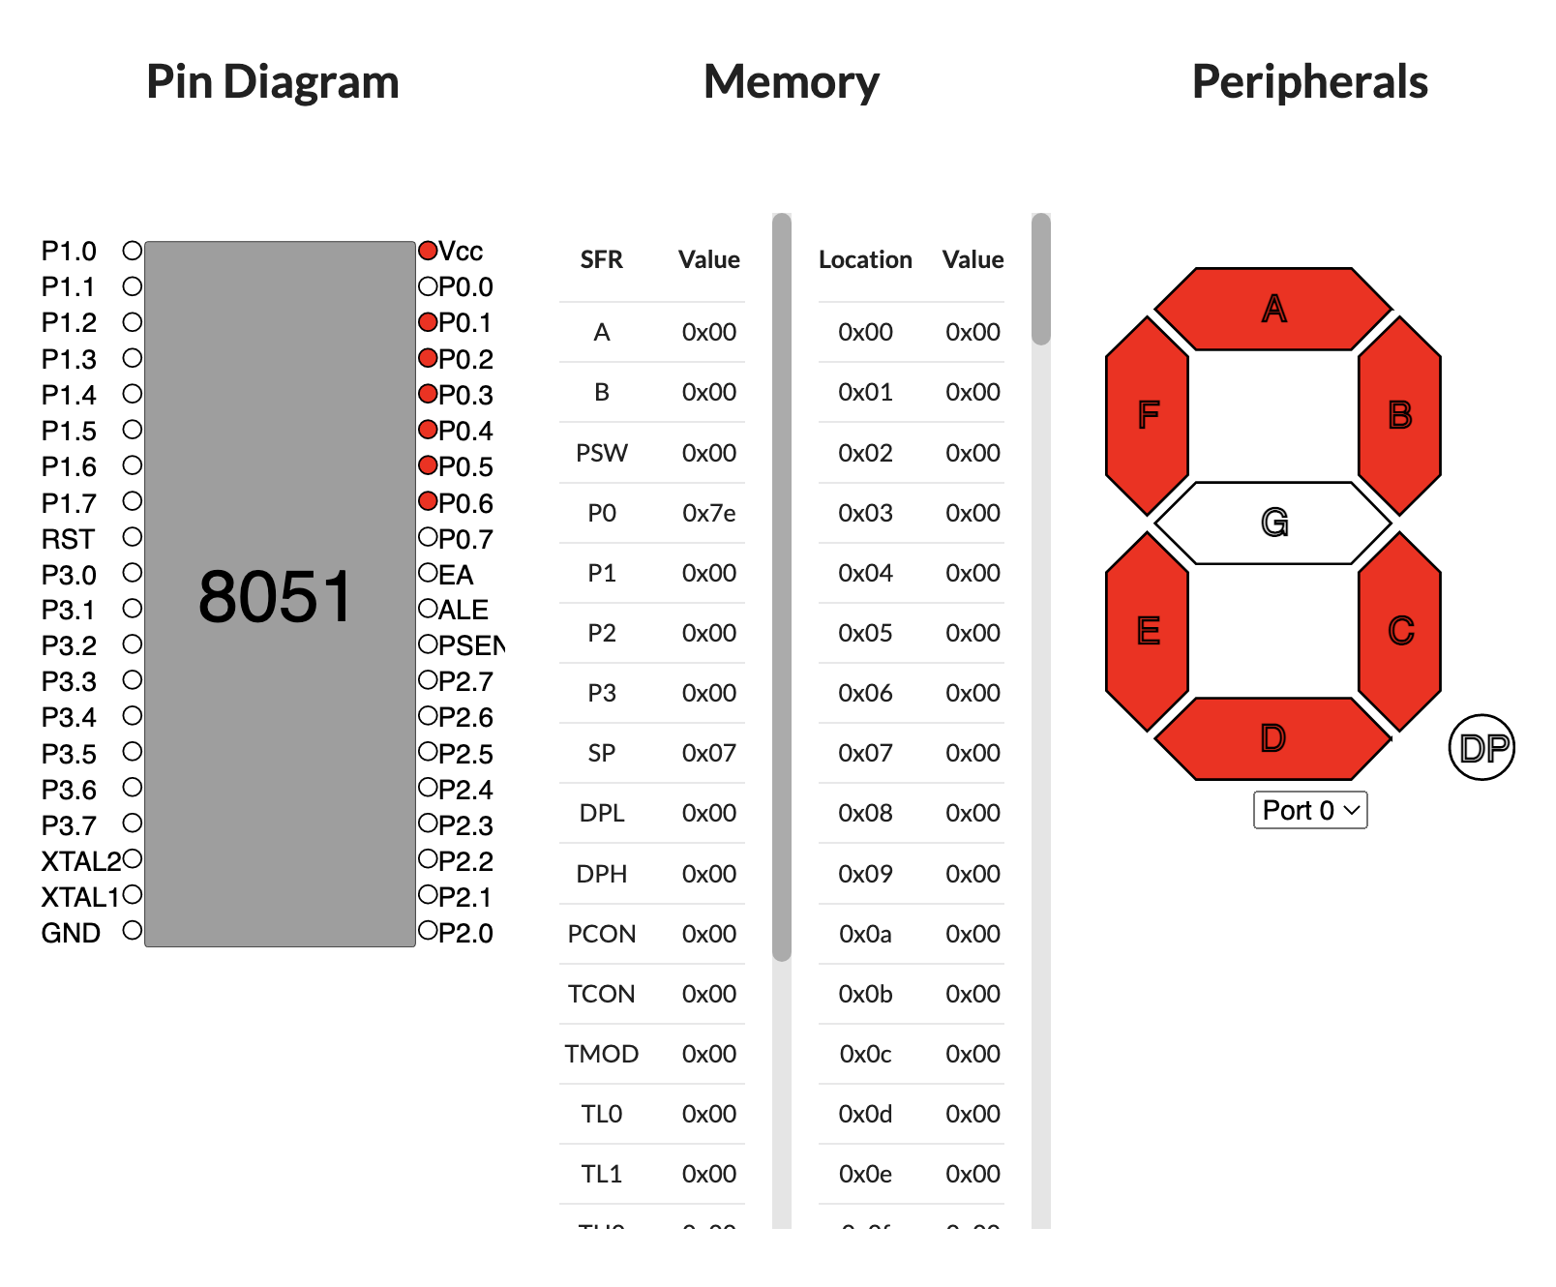

Configuration to display 0

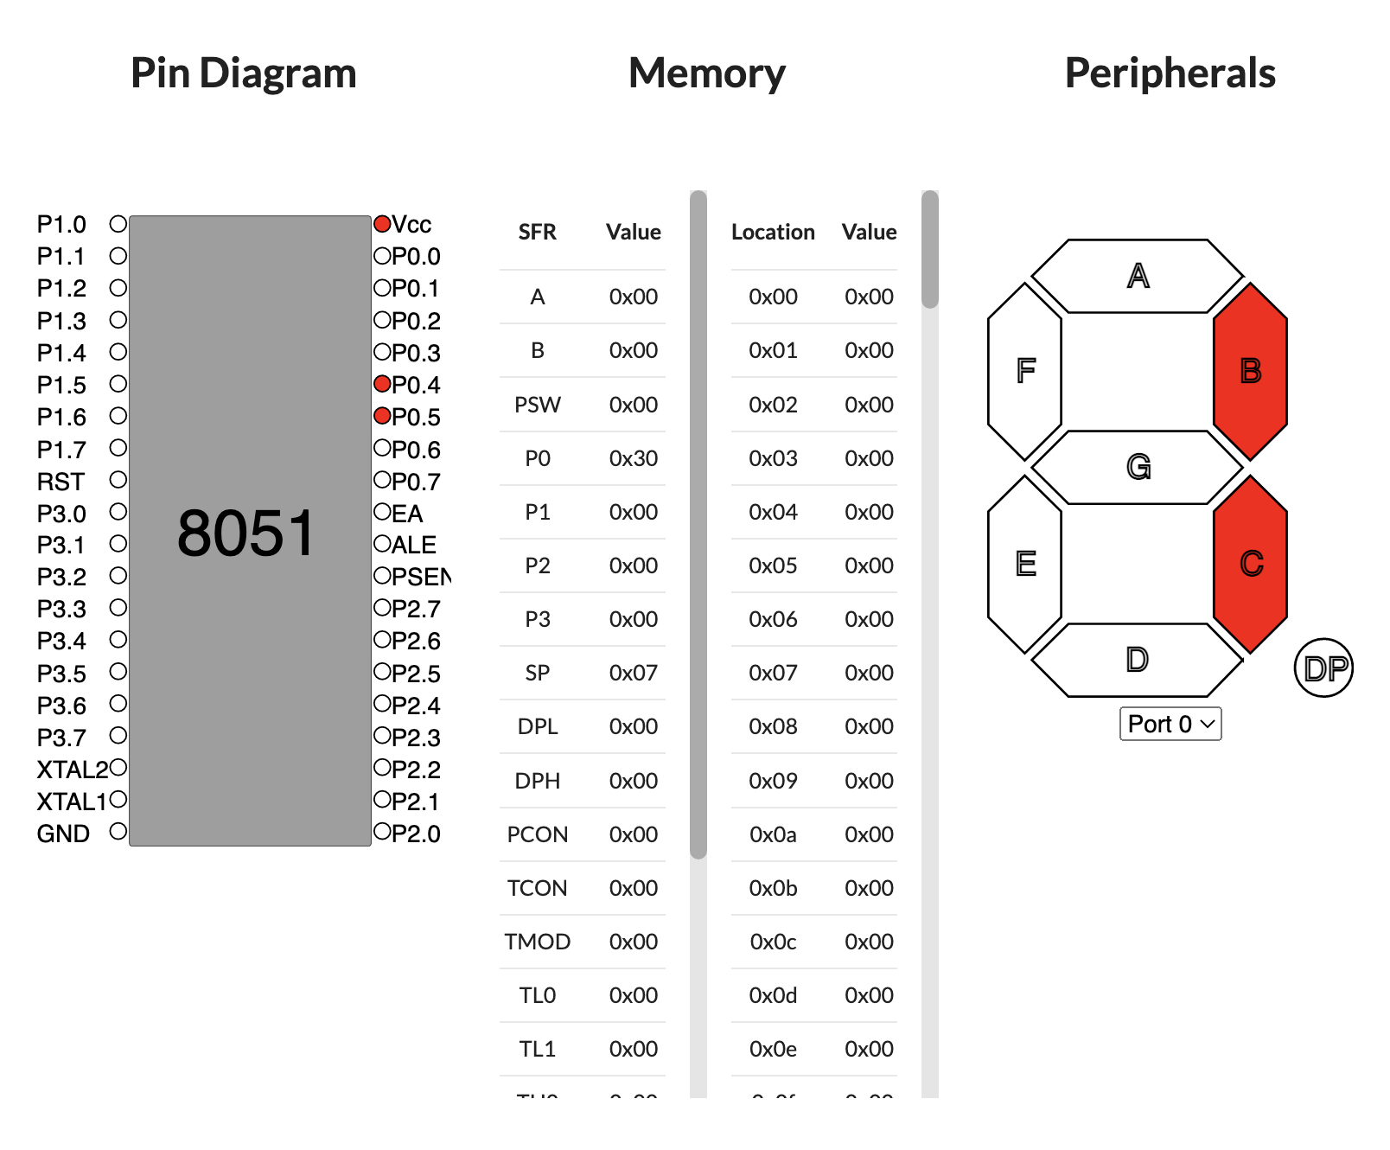

Configuration to display 1

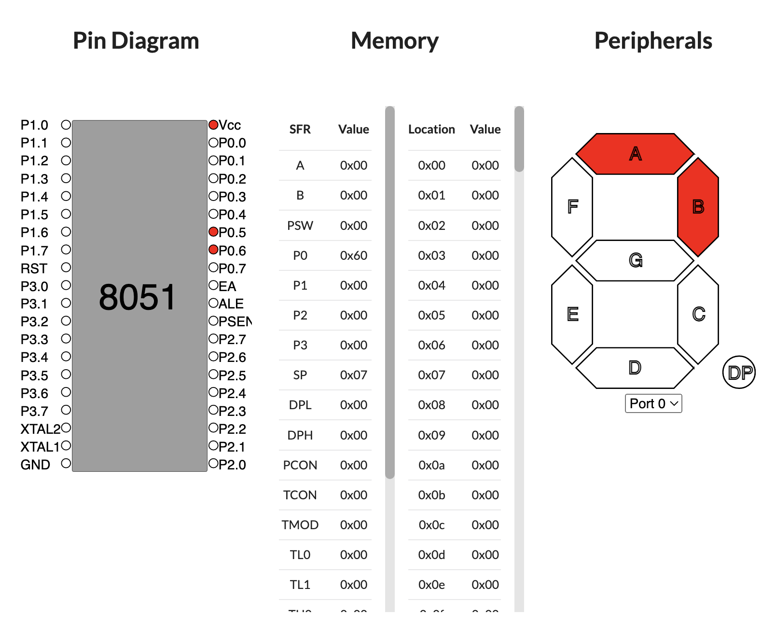

Configuration to display 2

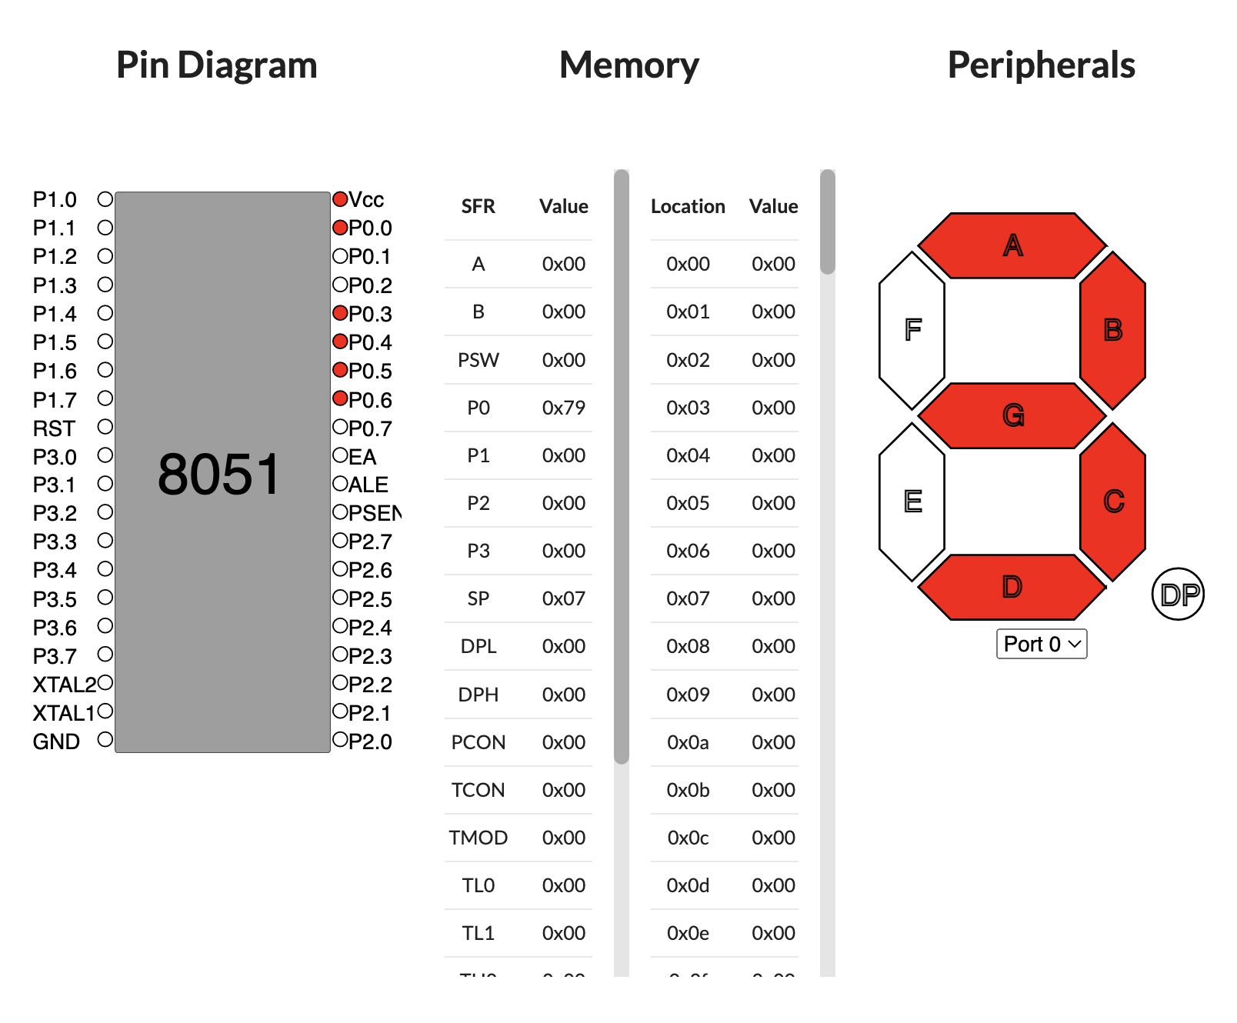

Configuration to display 3

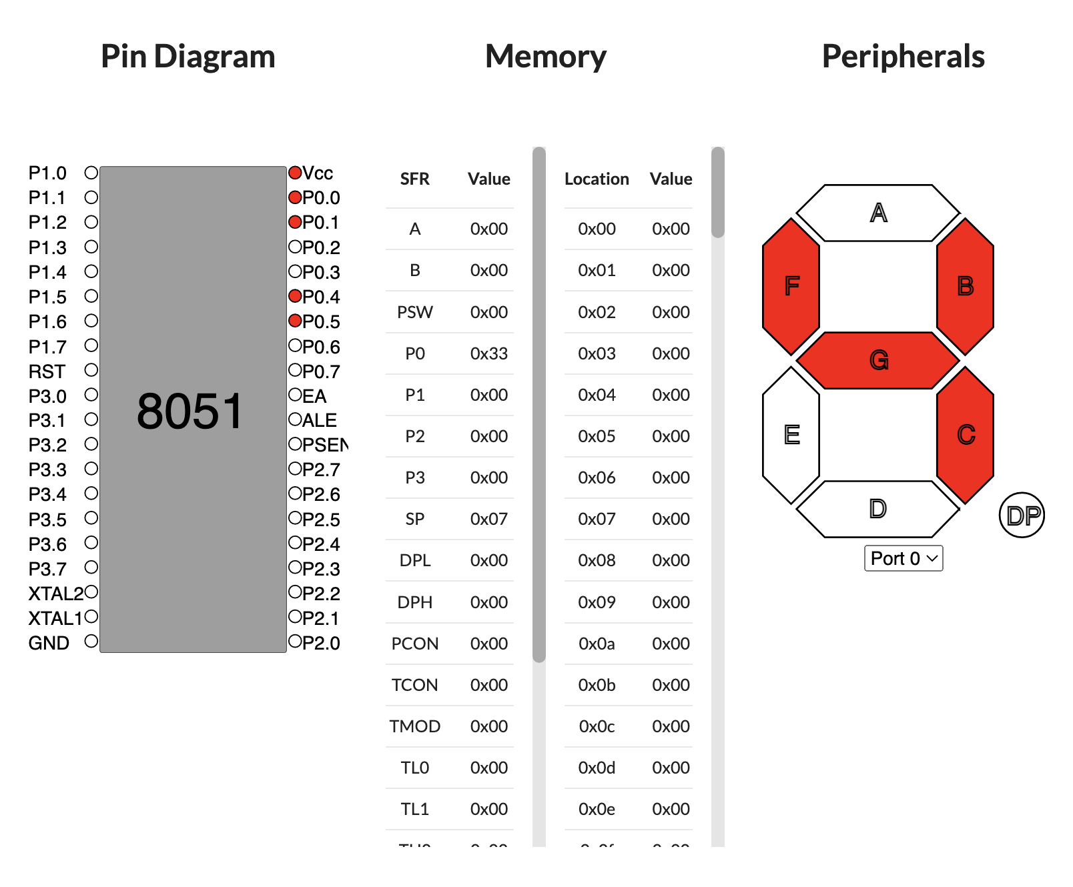

Configuration to display 4

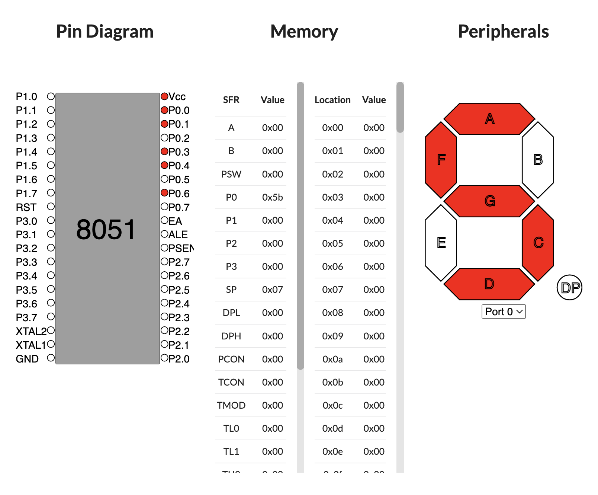 Configuration to display 5

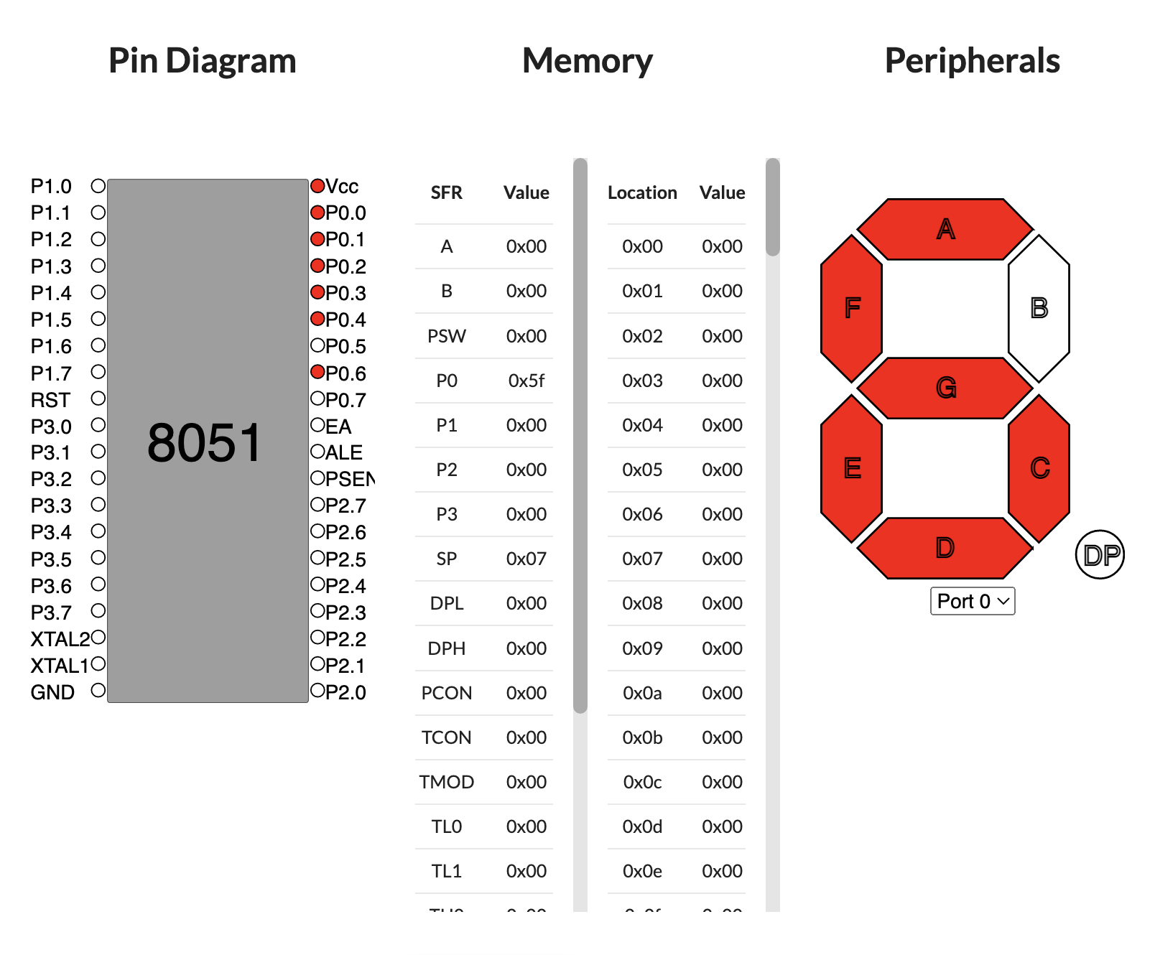 Configuration to display 6

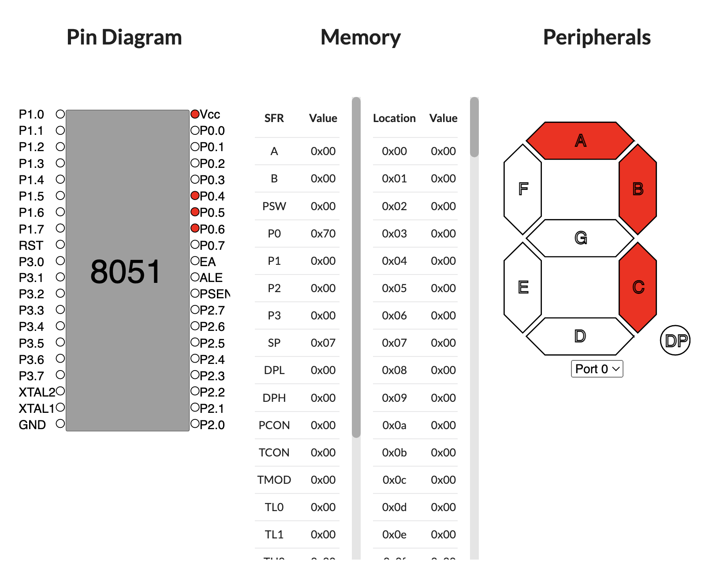

Configuration to display 7

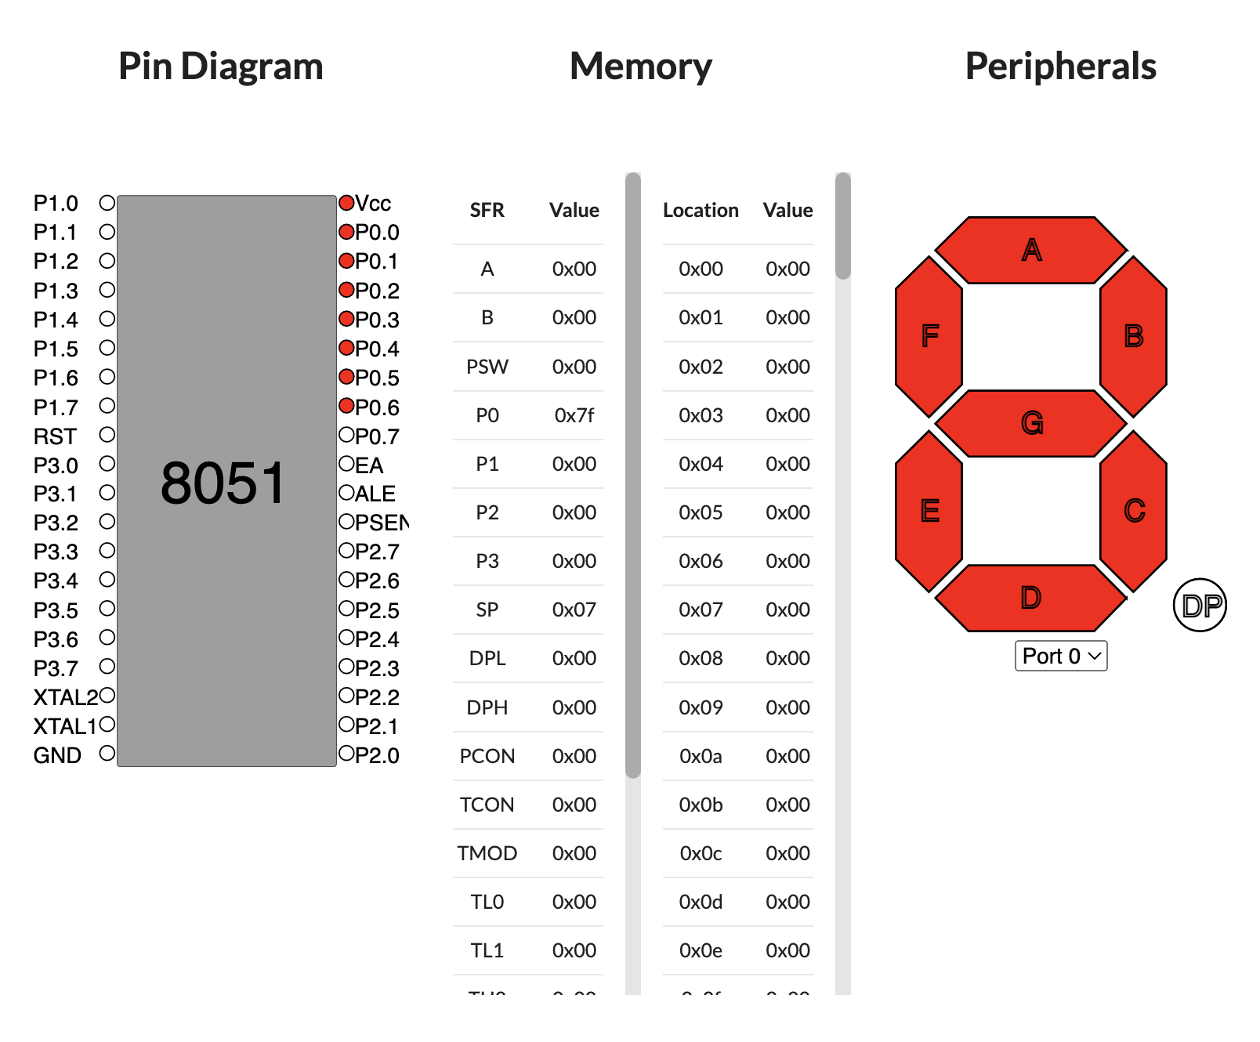

Configuration to display 8

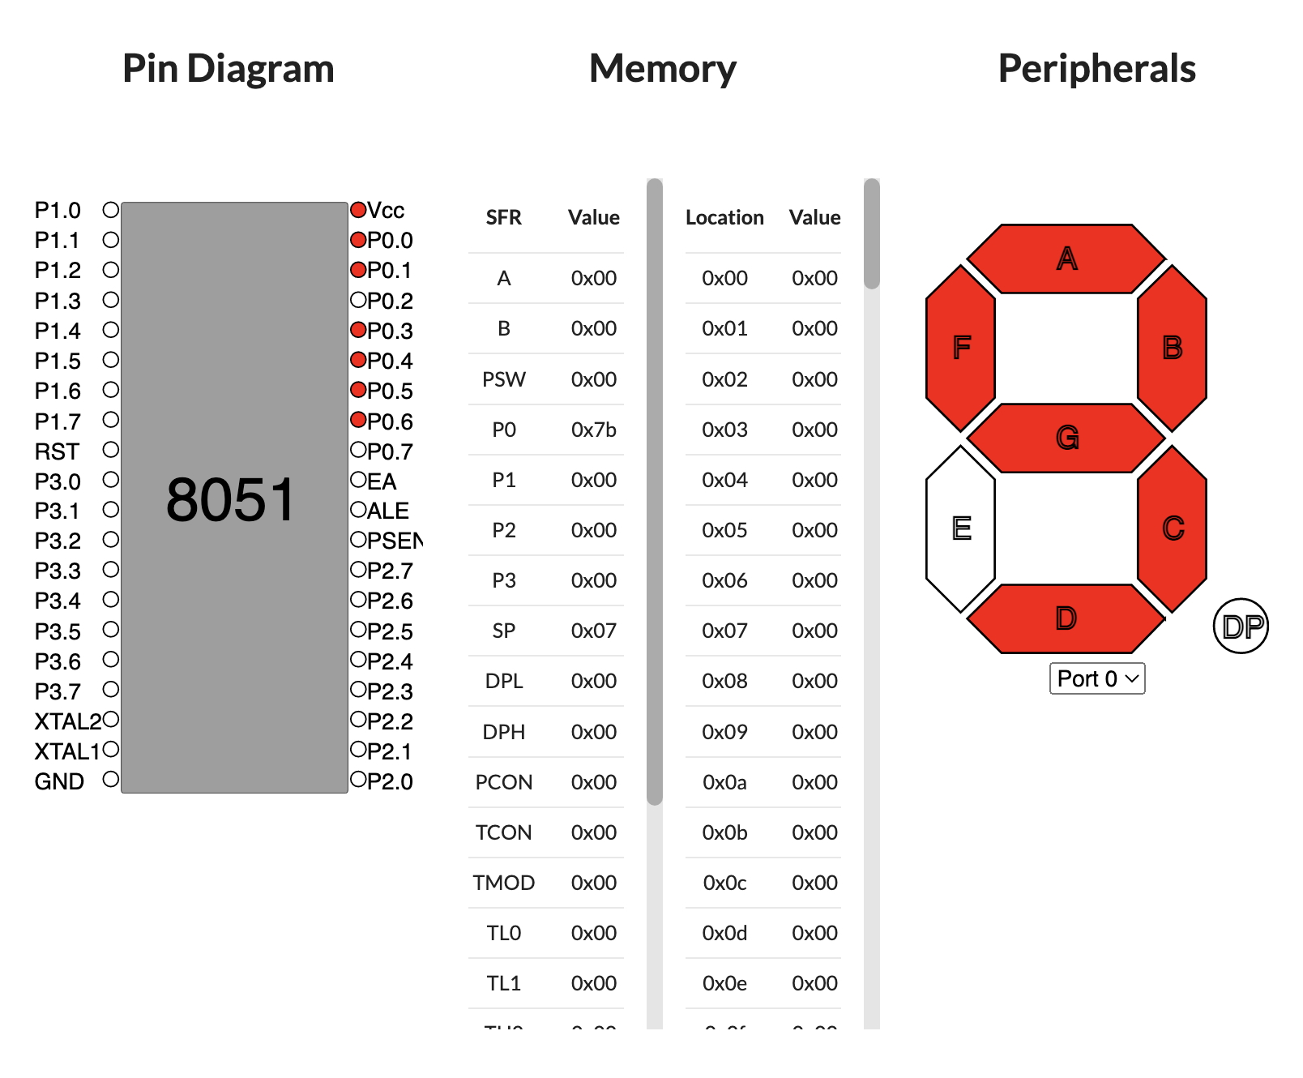 Configuration to display 9

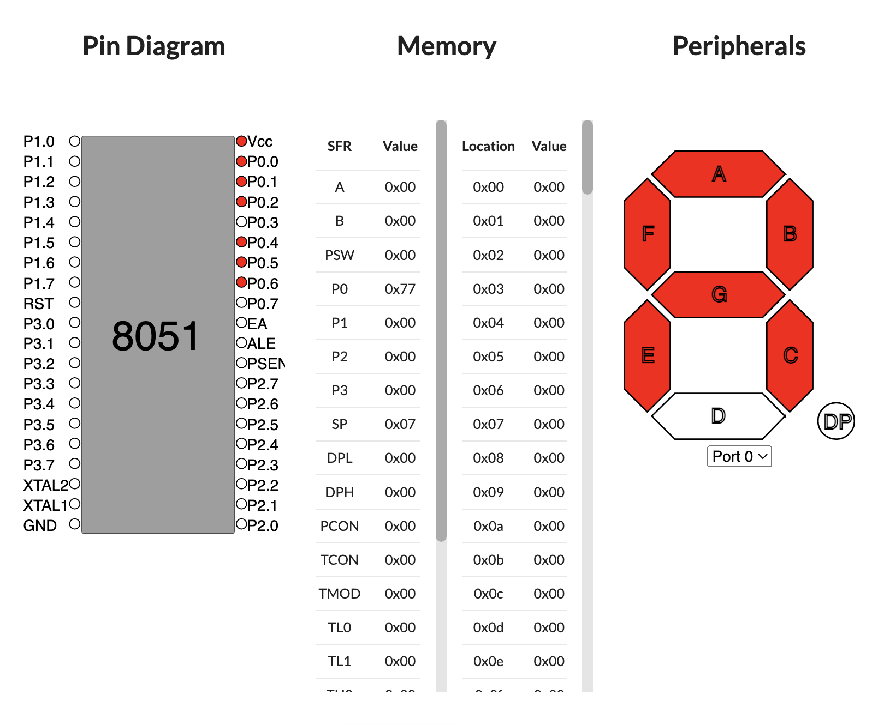 Configuration to display A

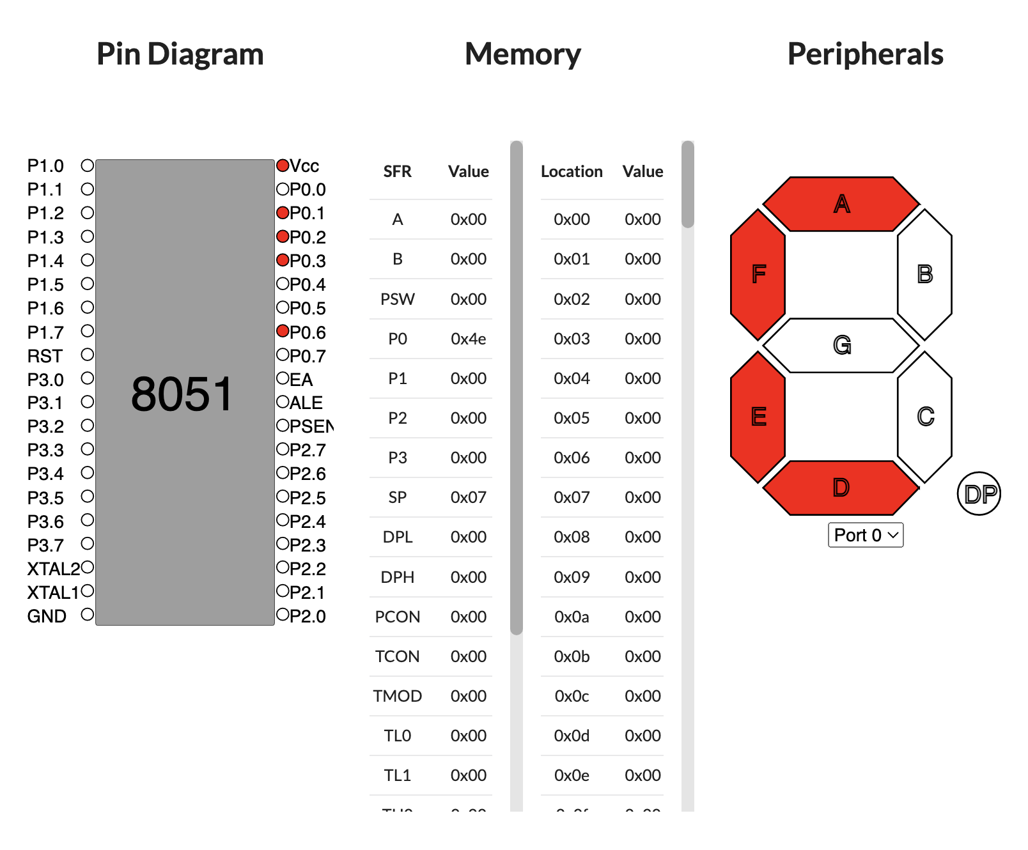

Configuration to display C

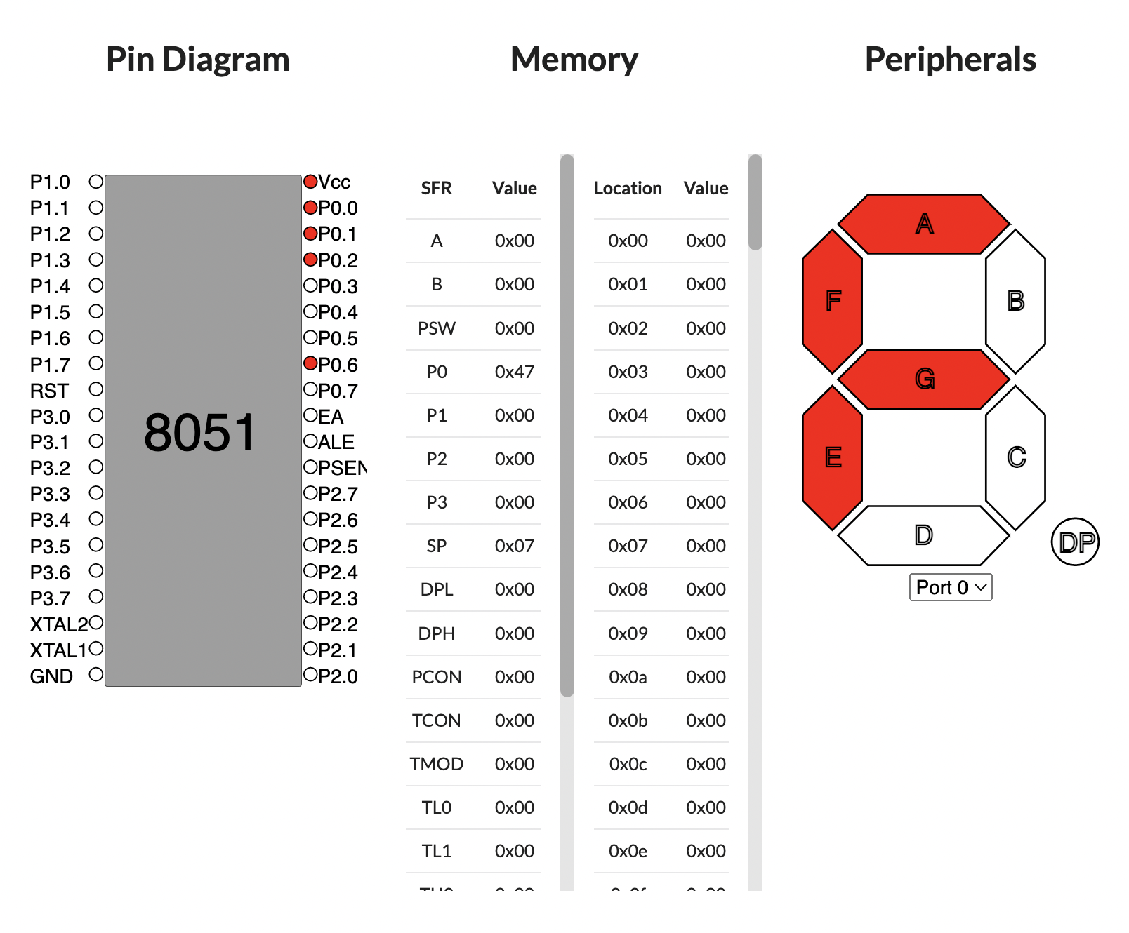 Configuration to display F

**Lab 10**

**Title: LED blinking experiment using 8051 micro controller using hardware kit**

**Aim:**

To realize the toggling of LED using 8051 micro-controller with the help of Keil and Proteus

software

Procedure:

KEIL Software:

1) Open Keil uvision Software

2) Click on Project Tab. Click on New vision Project.

3) Give name to your project.

NXP

4) Choose controller manufacturer (ATMEL) and choose the device AT89e91: Click

5) Then click on No.

6) Click on the file tab and then select New file and save the file. 7) Write your C program and save it.

3) Click on mark besides Target 1 and then right click on Source Group I and then select "Add files to

Source Group 1.

9) Select the file name and then click on add

10) After adding source file to the source group. Just build once, check errors and warnings for program 11) Next step is to create Hex File.

12) To create HEX file select Target I and right click and then select "Options for Target Target

13) Change oscillator frequency to 11.0592 MHz and highlight Use On-chip ROM.

14) Click on Output and highlight Create HEX and then click on OK

15) Click on Project Tab and click on Build target.

Flash Magic Procedure: Reference:

https://www.exploreembedded.com/wiki/LPC2148: Uploading .hex_file_usi ng Flash Magic

1.Hex Using Flash Magic

You need a USB to Serial(UART) converter in order to get this working. The neat thing about the NXP controllers is, they come with a UART bootloader from the factory.

Now open the flash magic software and follow the below steps.

1. Select the IC from Select Menu.

8945/RD2

2. Select the COM Port. Check the device manager 3. Select Baud rate from 9600-115200 4600

4. Select None Isp Option.

5. Oscillator Freq 12.000000(12Mhz).

un 6uxCheck the Erase blocks used by Hex file option step. I chuck Brase all bath.

7. Browse and Select the hex fileps 8. Check the Verify After Programming Option.-step → Excute (cheen)

9. If DTR and RTS are used then go to Options->Advanced Options-> Hardware Config and select the Use DTR and RTS Option.

10.Hit the Start Button to flash the hex file

-Step-5 plz chek

11.Once the hex file is flashed, Reset the board. Now the controller should run your application code.

for detected Com port. → Com)

Keil C Code and Hex file:

C:\Keil\C51\Examples\HELLO\LED-BLINK.c (HEX)

#include<reg51.h>

void main()

{

unsigned char x, y;

unsigned int i;

P1 = 0x00; // Output Configuration

while(1)

{

x=0x01; // 00000001 b

for (y = 0; y < 8; y++)

{

P1 = x; for (i=0; i< 60000; i++)

{

x=x<< 1;

}

}

}

Screenshots: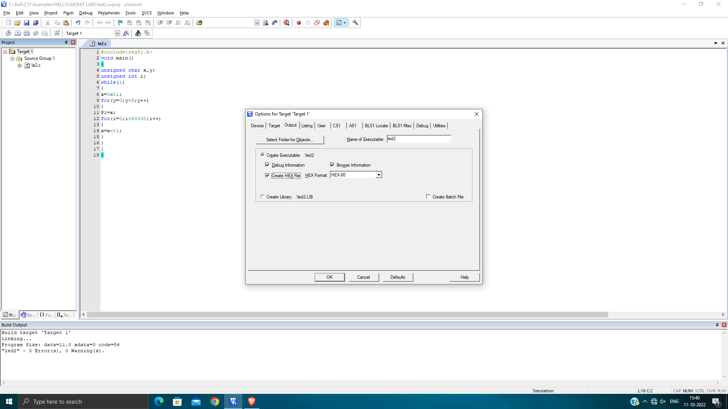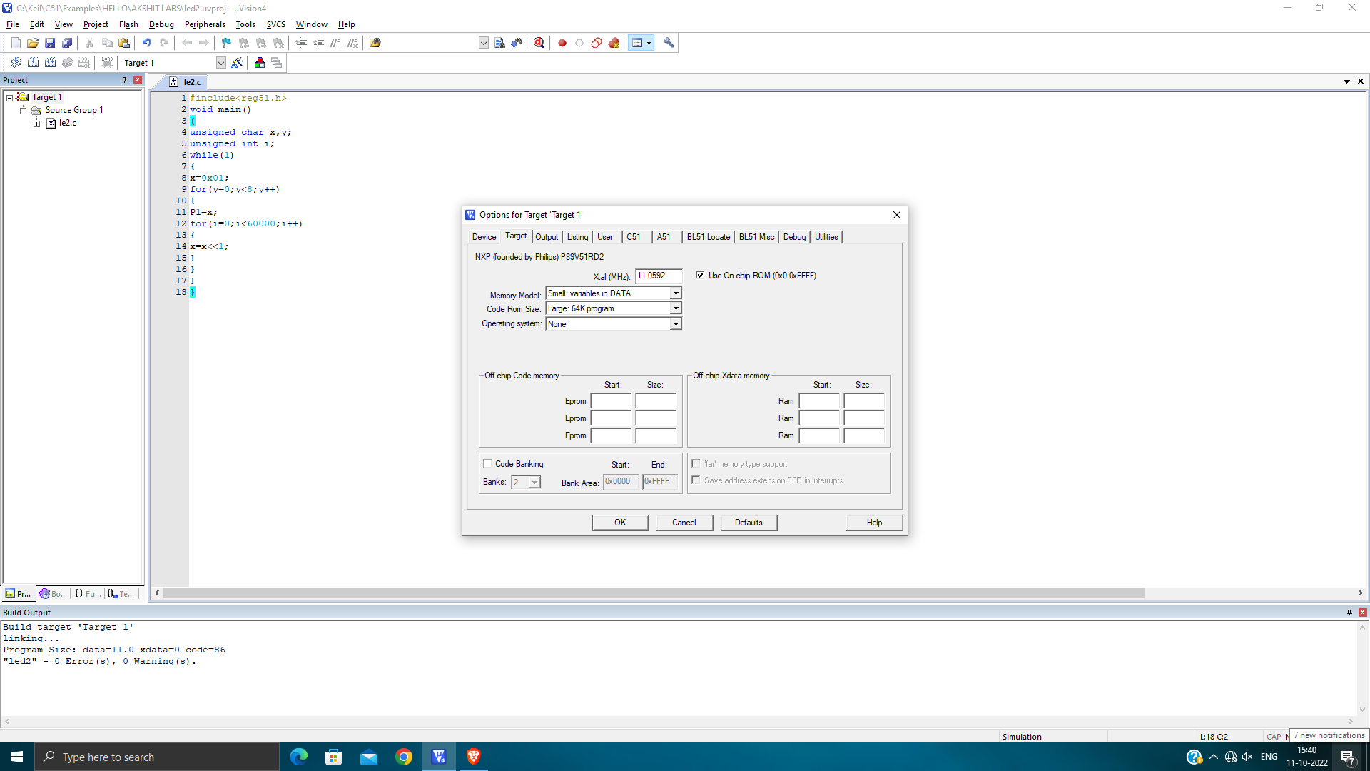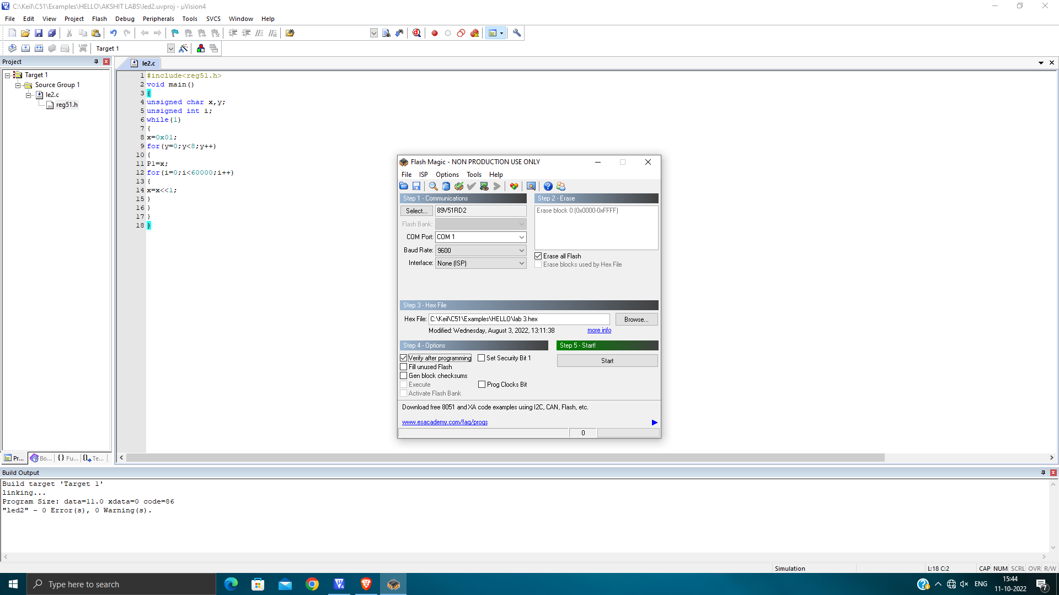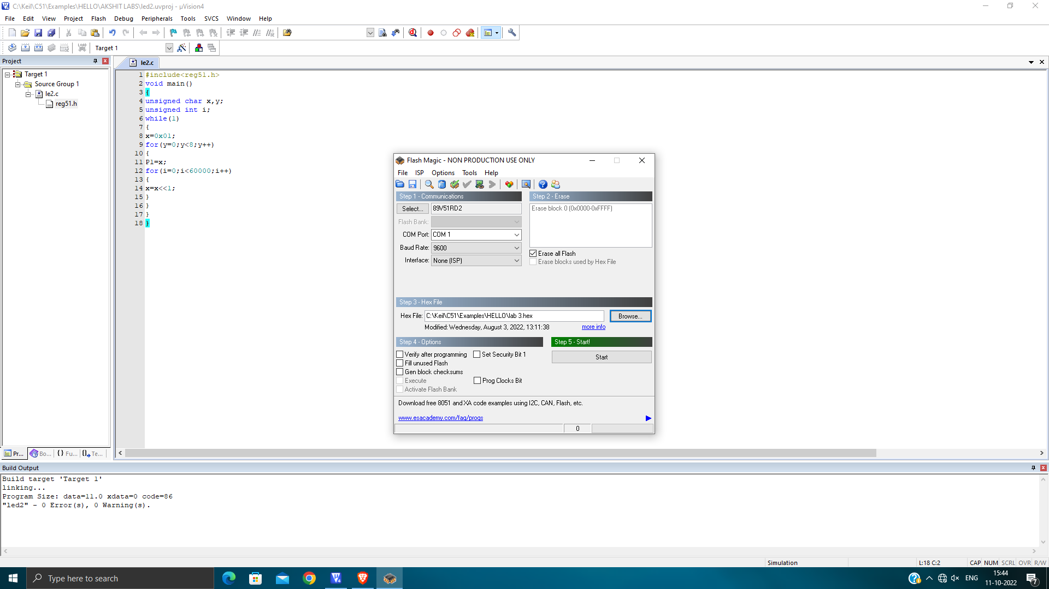

**Lab 11**

**Title: LED blinking experiment using Arduino NANO using hardware kit.**

**Aim**- Perform the blinking experiment with Arduino nano Board

**Apparatus**- Arduino nano Board, USB Cable

**Steps-**

Open Arduino 1.8.19

Click on the File section, click on examples then click on Basics and then select Blink from the options.

From the tools section, click on board and select Arduino Nano.

From the tools section select processor as Atmega 328P (old Bootloader).

From the tools section select port as COM5.

After all the selections we need to press the reset button on the board to reset and then we compile the program and upload it to the Arduino nano board.

We can change the time interval in which we want the LED to blink in the code as per our preference.

**Code:**

**// the setup function runs once when you press reset or power the board**

**void setup() {**

**// initialize digital pin LED_BUILTIN as an output.**

**pinMode(LED_BUILTIN, OUTPUT);**

**}**

**// the loop function runs over and over again forever**

**void loop() {**

**digitalWrite(LED_BUILTIN, HIGH); // turn the LED on (HIGH is the voltage level)**

**delay(1000); // wait for a second**

**digitalWrite(LED_BUILTIN, LOW); // turn the LED off by making the voltage LOW**

**delay(1000); // wait for a second**

**}**

Screenshots:

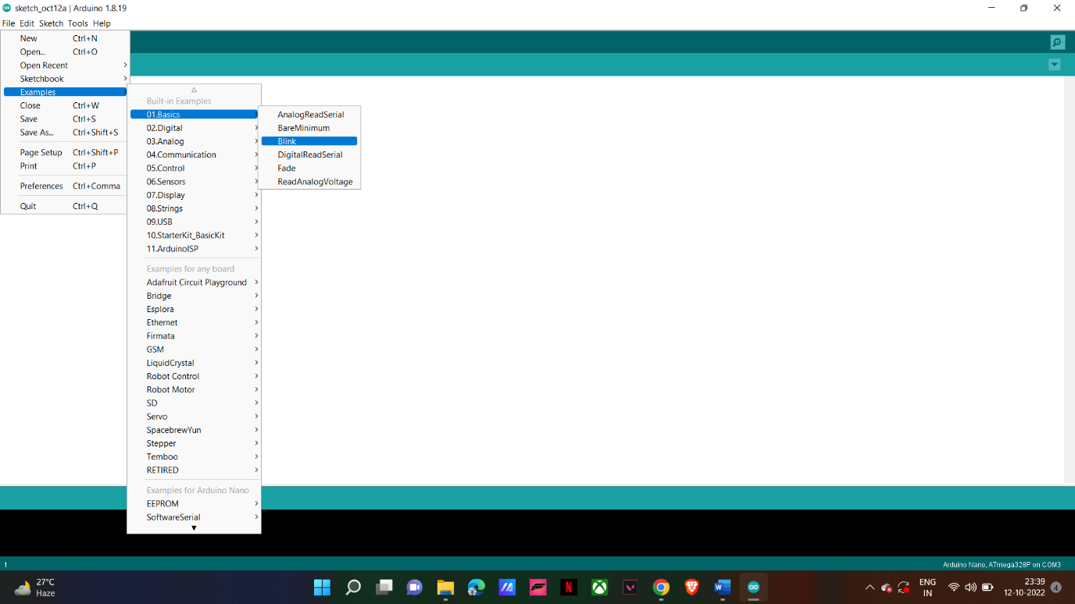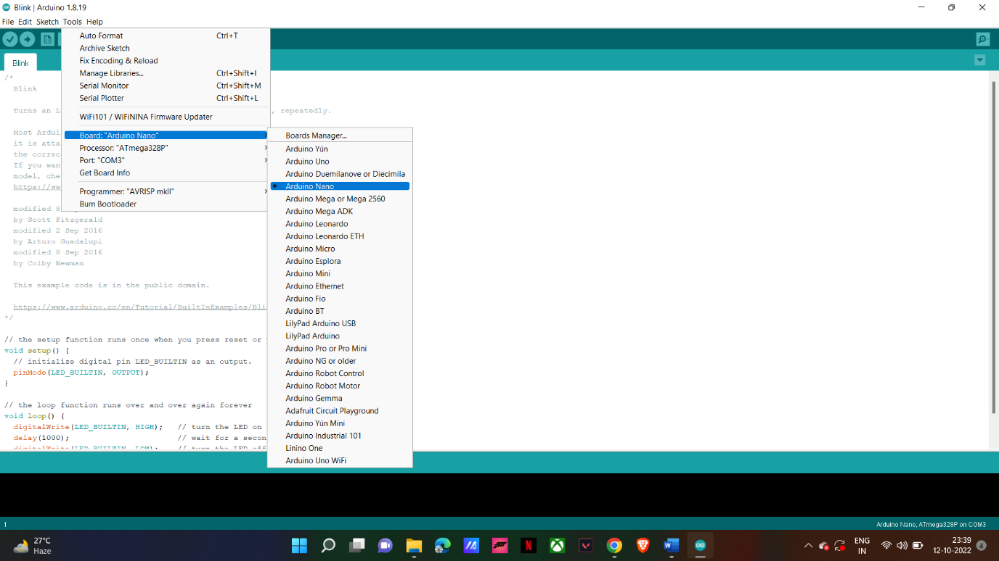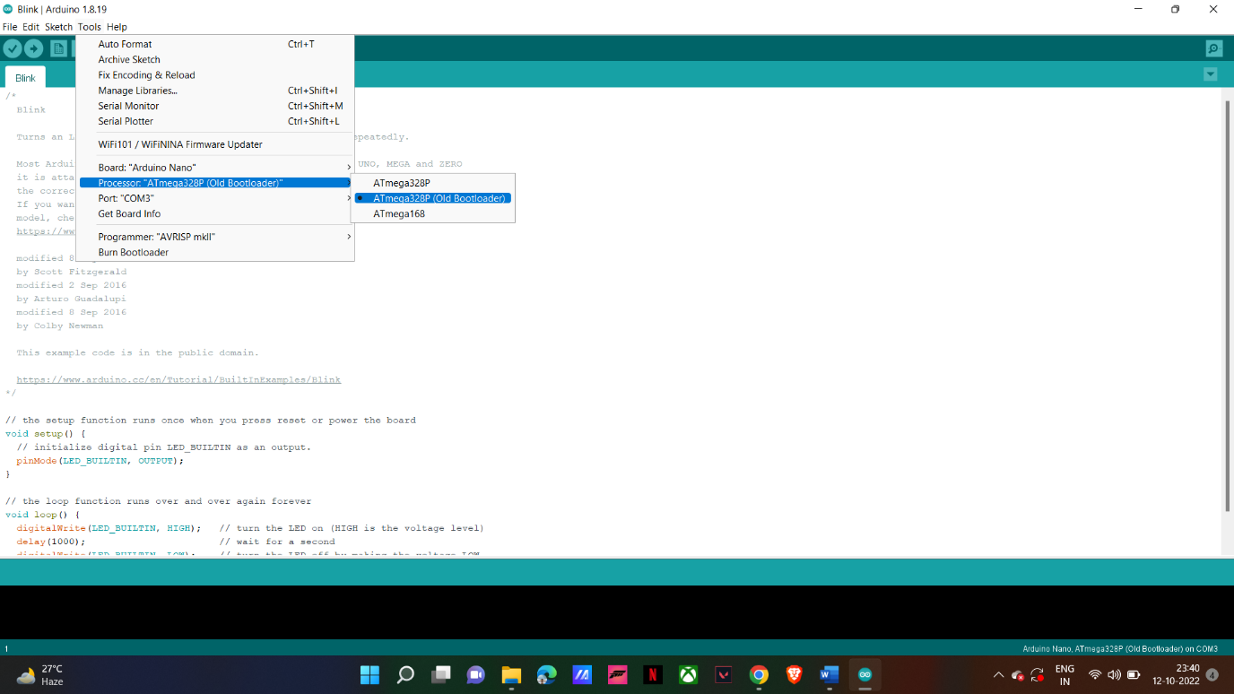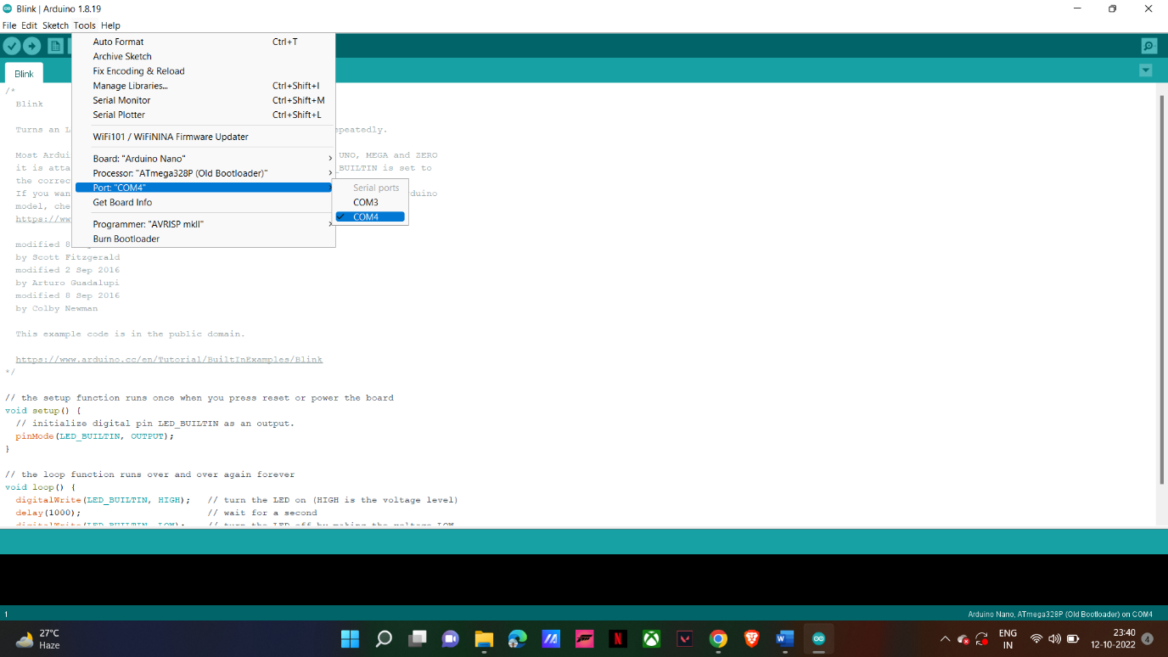

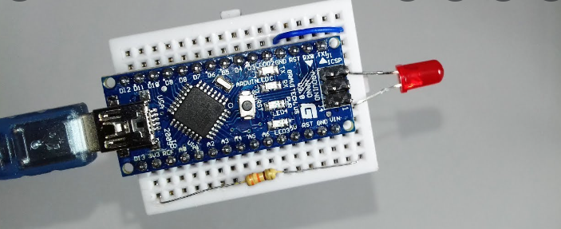

**Lab 12**

**Title: LED blinking experiment using Raspberry pi-PICO hardware using portable thonny.**

Aim: working with inbuild led with rasberry pi pico board.

Appratus : rasberry pi board , usb cable and thonny python software.

Code:

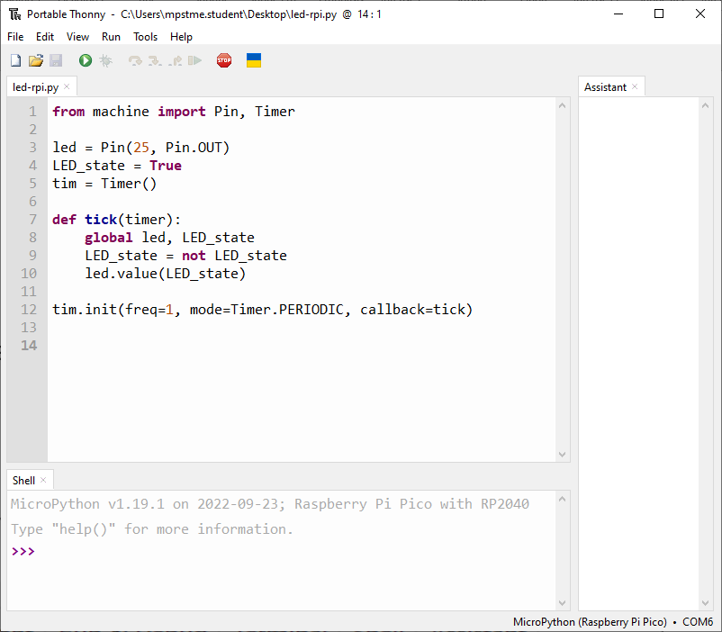

**Screenshots:-**

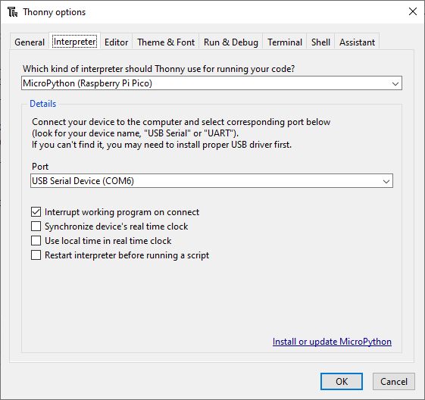

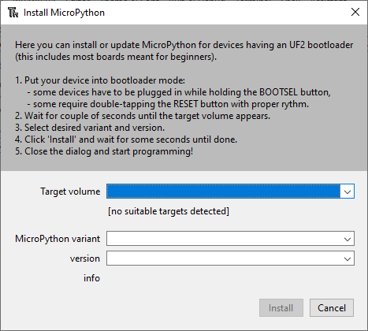

Output:

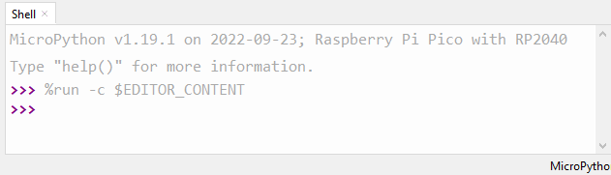

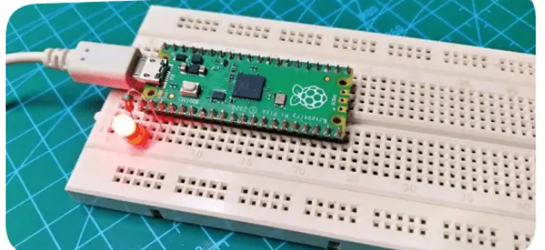

**Conclusion:**

We have successfully performed the led blinking on the raspberry pi board using the portable thonny software.

**Lab 13**

**Free RTOS**

1. Why Free RTOS?

A task can block any events, whether they are internal or external to the system, using Free RTOS. This means that when there are no events that need to be processed, there is no time wasted polling or checking timers. This may lead to significant reductions in processor usage. Program only runs when it is necessary.

Although its use is not only bound to microcontroller applications, Free RTOS is a kind of RTOS that is intended to be small enough to run on a microcontroller.

A microcontroller is a compact, resource-constrained CPU that combines the processor, readonly memory for the program to be run, and random access memory for the programs it runs all on a single chip.

2. What is the size of the free RTOS? The Free RTOS kernel is meant to be compact, uncomplicated, and straightforward to use. The size of an RTOS kernel binary image is typically between 4000 and 9000 bytes.

3. For what application RTOS can be used in embedded system?

Using an RTOS means you can run multiple tasks concurrently, bringing in the basic connectivity, privacy, security, and so on as and when you need them. An RTOS allows you to create an optimized solution for the specific requirements of your project.

Mutexes, semaphores, and software clocks are among the features offered by Free RTOS. For low power applications, a tickless mode is offered. Priorities for threads are supported.

4. How task scheduling can be done in RTOS?

Preemptive scheduling methods and non-preemptive scheduling algorithms can be used to categories them.

• Preemptive Scheduling.

• Non-preemptive Scheduling

• First Come, First Served (FCFS) • Shortest Job First (SJF) • Priority Scheduling.

• Round-Robin Scheduling

5. What are the HARDWARE requirement for implementation of RTOS based program.

• The Scheduler

• Symmetric Multiprocessing

• Function Library

• Memory Management

• Fast Dispatch Latency

• User-Defined Data Objects

• Classes are all significant RTOS system components. There are three different forms of RTOS:

• Soft time

• firm time

• Hard time